The Needs-based Model of Reconciliation: How Identity Restoration Processes Can Contribute to More Harmonious and Equal Social Relations

Nurit Shnabel¹, Johannes Ullrich² & Arie Nadler¹
¹ School of Psychological Sciences, Tel Aviv University, Israel
² Department of Psychology, University of Zurich, Switzerland

Author Note
Nurit Shnabel https://orcid.org/0000-0003-2994-6759
Johannes Ullrich https://orcid.org/0000-0002-0471-7004
Arie Nadler https://orcid.org/0000-0002-7411-2887
We have no known conflict of interest to disclose.
Correspondence concerning this article should be addressed to Nurit Shnabel,
Email: shnabeln@tauex.tau.ac.il

Abstract
The needs-based model is a conceptual framework for understanding the identity-related aspects of reconciliation processes. According to the model, (a) conflicting parties experience threats to their agentic (victims) and moral (perpetrators) identities — leading to heightened needs for empowerment and acceptance, respectively, and (b) satisfying these needs increases victims’ and perpetrators’ readiness for reconciliation. In this chapter, we review studies testing the model in interpersonal and intergroup contexts. We apply the model to conflicts characterized by mutual transgressions and discuss different ways victims’ and perpetrators’ identities can be restored (e.g., via empowering and accepting messages from the other or a third party, identity-affirmation exercises). We also apply the model to contexts of structural inequality by (a) presenting evidence that intergroup contact that satisfies disadvantaged and advantaged group members’ needs for empowerment and acceptance is associated with their support for change, (b) discussing the moderating role of system justification, and (c) integrating our findings with the rank-based perspective on social class. Finally, we discuss the model’s boundary conditions and directions for future research.

Keywords: the needs-based model, reconciliation, empowerment, acceptance, agency, morality, communion, need satisfaction, identity restoration, social identity

The needs-based model of reconciliation: How identity restoration processes can contribute to more harmonious and equal social relations
The concept of reconciliation gained prominence in social psychology in the early 2000’s. In the study of interpersonal relations, interest in reconciliation processes was sparked by ethology and primatology research, whose focus gradually shifted from primarily studying conflict and violence to a greater emphasis on understanding prosocial mechanisms for harmony maintenance and restoration (see Verbeek & Peters, 2018). In the study of intergroup relations, reconciliation processes were put on the agenda by efforts to ‘heal’ post-conflict communities (e.g., in post-genocide Rwanda; Staub, 2008), the increasing use of apologies in the public sphere (Wohl et al., 2011; e.g., Pope John Paul II’s apology to the Jews for 2,000 years of persecution by the Catholic Church), and the truth and reconciliation commissions in South Africa and elsewhere (Nadler et al., 2008). The theoretical framework of the needs-based model presented in this chapter was developed as part of this growing scientific interest in reconciliation processes.
The goal of the present chapter is to review and integrate the empirical evidence gathered through research on the model. The first section presents the model’s basic assumptions. In the second section, we review empirical findings from interpersonal and intergroup contexts in which there are clear-cut roles of ‘victims’ and ‘perpetrators.’ In the third section, we review studies that applied the model to contexts of interpersonal and intergroup conflicts in which both parties view themselves simultaneously as ‘victims’ and ‘perpetrators.’ In the fourth section, we consider the role of identity restoration outside of the victim-perpetrator dyad (through messages from third parties or identity affirmation exercises) in promoting reconciliation. In the fifth section, we review studies that tested the model in contexts of intergroup relations characterized by structural inequality (i.e., among advantaged and disadvantaged social groups). In the last section, we discuss promising directions for future research within the model’s framework (e.g., practical application of its insights) as well as its critical boundary conditions.
- The basic assumptions of the needs-based model
Perhaps one reason for the relatively late introduction of the concept of ‘reconciliation’ into the social psychological discourse is that it is elusive and difficult to define. We have thoroughly discussed the complexity associated with the conceptualization of reconciliation elsewhere (e.g., whether it denotes a process or an outcome, or how it is distinct from related concepts such as ‘conflict resolution’). Interested readers can refer to Nadler (2012; see also Nadler & Shnabel, 2015). For the purpose of the present chapter, we focus on ‘willingness to reconcile,’ as a key construct that is indispensable for reconciliation (whether conceptualized as a process or outcome). This construct captures the conflicting parties’ general positive, prosocial orientation towards each other, i.e., the parties’ belief that the relationship can be improved in the future and willingness to invest effort in promoting such improvement.
Social psychological research has demonstrated that the willingness of conflicting parties to reconcile is influenced by a host of factors. For example, the willingness of romantic couples to reconcile following transgressions is affected by their level of commitment to each other, which increases if they have already invested substantial resources in the relationship (Rusbult et al., 1986), and the willingness to reconcile among members of groups involved in an intractable conflict is affected by their perceptions of intergroup relations as zero sum in nature (Bar-Tal, 2013). The unique contribution of the needs-based model to the reconciliation literature is its focus on the influence of factors related to the conflicting parties’ identities. According to this model, conflicts threaten victims’ and perpetrators’ positive identities. Because people are motivated to maintain a positive identity, whether as individuals (Steele, 1988) or members of social groups (Tajfel & Turner, 1979), victims and perpetrators experience heightened needs to restore their positive identities. Building on the view of reconciliation as an identity change process (Kelman, 2008), the model suggests that satisfying victims’ and perpetrators’ need to restore their positive identities should increase their willingness to reconcile with each other—whereas leaving these needs unsatisfied should hinder reconciliation.
To understand the nature of the differential threats posed to victims’ and perpetrators’ identities, the model then turns to theorizing about the “Big Two” (Abele et al., 2020). Several theoretical models in social psychology, such as the Dual Perspective Model by Abele and Wojciszke (2007) and the Stereotype Content Model by Fiske et al. (2002) converge on the notion that there are two fundamental content dimensions along which people evaluate social targets (for a comparison and integration of the five main models, see Koch et al., 2021): the agency dimension, representing traits such as ‘strong,’ ‘competent,’ ‘influential,’ and ‘self-determined,’ and the moral-social dimension (also known as the communion dimension), representing traits such as ‘moral’, ‘warm’ and ‘trustworthy.’ The needs-based model argues that individuals or members of groups that have been victimized (‘victims’) experience a threat to their agentic identity, whereas individuals or members of groups that have transgressed against others (‘perpetrators’), experience a threat to their moral identity.
These identity threats bring about different motivational states: Victims experience the need to regain voice, value, and sense of agency (i.e., ability to determine their own outcomes), whereas perpetrators experience the need to regain a self-image as moral and acceptance into the community from which they feel potentially excluded. Perpetrators fear exclusion, because it is the sanction imposed upon those who violate the norms or moral standards of their community (Schachter, 1951; Tavuchis 1991). Put differently, victims are motivated to restore their agentic identity, and perpetrators to restore their moral identity, which is critical for social inclusion. As long as these needs remain unsatisfied, victims and perpetrators might be motivated to behave in ways that further escalate the conflict. Victims’ need to restore their agentic identity might lead to aggressive, vengeful behavior (Frijda 1994). Perpetrators’ need to restore their moral identity might lead to moral disengagement, such as minimizing the severity of the harm or blaming the victims for bringing it upon themselves (Bandura, 1990). However, when victims’ and perpetrators’ respective needs for empowerment and acceptance are satisfied, their readiness to reconcile with each other should increase.
A paradigmatic social mechanism through which perpetrators and victims can satisfy each other’s needs is the ‘apology forgiveness cycle.’ Victims’ expressions of forgiveness can mitigate the moral inferiority engendered by the perpetrator role (Exline & Baumeister 2000), whereas perpetrators’ acknowledgment of culpability constitutes an admission of owing a moral debt to the victims (Minow 1998), which can return control to the victims. Other ways through which victims may satisfy perpetrators’ need for moral acceptance include the expression of sympathy for the perpetrators’ emotional distress or understanding for the circumstances that compelled their actions. Other ways through which perpetrators may satisfy victims’ need for agency include praising the victims’ achievements and capabilities or giving them voice (i.e., listening to and respecting their point of view; Bruneau & Saxe, 2012). Figure 1 summarizes the processes proposed by the needs-based model.
[INSERT FIGURE 1 ABOUT HERE]
Before we review the empirical evidence that supports the model, a word of clarification may be in order. As implied by the above explanation about the different ways empowerment and acceptance can be manifested, these two concepts are broadly defined and can mean different things in different contexts. For example, when a perpetrator group has previously denied its culpability (e.g., Turkey’s denial of the Armenian genocide; Bilali, 2013), the mere acknowledgement of the injustice can be empowering for the victim group. However, when culpability has already been acknowledged (e.g., Canada’s apology to the First Nations People), additional steps besides the admission of guilt, such as compensation and redistribution policies, are required to empower the victims (see Wohl et al., 2011). Similarly, victims’ willingness to maintain cooperative relations with the perpetrators can imply moral acceptance in some situations (e.g., Jewish withdrawal of the boycott on German products), but not in others (see Brambilla et al., 2021, and Leach et al., 2007, for the distinction between morality and sociability). In other words, when applying the model’s insights to a given context of conflict, it is important to pay attention to the particular history of that conflict. In addition, because both empowering and accepting gestures or actions are positive in tone, perceptions of empowerment and acceptance will often be positively correlated (see Hässler et al., 2022). To illustrate, according to Social Resources Theory (Foa & Foa, 1980), a colleague praising the talents of another colleague with whom they are in conflict provides them with the resources of both ‘love’ and ‘status’ (corresponding to acceptance and empowerment in the needs-based model’s terminology). Nevertheless, we argue that the conceptual distinction between empowerment and acceptance provides valuable insights for understanding reconciliation processes.
- Empirical support for the needs-based model’s basic hypotheses
2. 1. Testing the model in contexts of interpersonal transgressions
The model was first put to an empirical test in the context of interpersonal transgressions. In this first test, we conducted a series of experiments using diverse methods (i.e., transgressions ‘orchestrated’ in the lab, recollection of real-life transgressions, and role-playing scenarios; see Shnabel & Nadler, 2008). Here we focus on the findings of Study 4 and a registered replication of it (Baranski et al., 2020), which was conducted as part of the Many Labs 5 project (Ebersole et al., 2020).
In the original study (Shnabel & Nadler, 2008, Study 4), participants (N = 94) were Israeli undergraduates who read a short vignette. The vignette, which was based on a pilot study in which Israeli undergraduate students wrote about a transgression experienced in their real lives, was about an employee who took off two weeks from work for maternity leave (for women) or military reserve duty (for men). Upon returning to the office, the employee learned that a colleague who temporarily filled their position was ultimately promoted to their job and they themselves were demoted. Participants assigned to the role of the victim were asked to imagine themselves as the demoted employee, and participants assigned to the role of the perpetrator were asked to imagine themselves as the promoted employee. Different from the vignettes used in previous research describing transgressions such as plagiarizing a friend’s paper or having sex with a friend’s fiancé (Gonzales et al., 1992), we intentionally used a vignette that does not reflect vicious or inexcusable behavior (e.g., the perpetrator may justify their behavior by claiming the boss to be responsible for the demotion). Specifically, our pilot study indicated that participants perceived the perpetrator’s behavior as violating the moral principles of loyalty, reciprocity, and fairness, arguing that had the perpetrator behaved morally, they would have refused to take the place of a colleague on maternity leave or reserve duty. Nevertheless, the perpetrator could at least partially excuse their behavior by placing the blame on the boss who made the decision regarding the demotion. This partial ambiguity reflects our theoretical stance that purely ‘evil’ behavior is rare: when accounting for their behavior, perpetrators can usually justify it (e.g., by referring to the compelling circumstances, Schönbach, 1990).
After the assignment to social roles (victims or perpetrators), participants completed self-reported measures of their sense of agency, moral image, needs for empowerment (e.g., wish to have greater control over the situation) and acceptance (e.g., wish that the other employee would perceive them as a moral person), and willingness to reconcile with the other employee. Then, participants received the second part of the vignette, which described a subsequent staff meeting in which the other employee gave them some feedback. In the ‘empowerment’ condition, participants learned that this other employee praised their professional skills, but made no mention of their interpersonal skills, whereas in the ‘acceptance’ condition the other employee praised their interpersonal skills but made no mention of their professional skills. Finally, participants again completed the measures of their sense of agency, moral image, and willingness to reconcile with the other employee.
The results fully supported the predictions of the model. In the first (‘before’) measurement, participants in the victim condition reported a lower sense of agency and a higher need for empowerment than participants in the perpetrator condition, who reported a lower moral image and a higher need for acceptance. Participants in the victim condition also reported less willingness to reconcile than participants in the perpetrator condition—an effect that is not directly predicted by the needs-based model, but that we have consistently found in our studies. It is consistent with Baumeister’s (1997) observation that perpetrators find it easier to ‘move on’ than victims.
When comparing the ‘before’ and ‘after’ measurements, we found that the empowerment (but not the acceptance) message increased participants’ sense of agency whereas the acceptance (but not the empowerment) message increased participants’ moral image. Consistent with the notion that perpetrators are readier to ‘move on,’ the change in participants’ willingness to reconcile was higher for perpetrators than for victims. Most important, there was a significant Time [before vs. after] × Role [victim vs. perpetrator] × Message [empowerment vs. acceptance] three-way interaction. We probed this interaction by examining the ‘before’ and ‘after’ responses separately. We found that after (but not before) receiving the feedback from the other employee, the willingness of victims to reconcile tended to be higher in the empowerment than in the acceptance condition, whereas perpetrators’ willingness to reconcile was higher in the acceptance than in the empowerment condition.
An initial attempt to replicate these findings was conducted by Gilbert (2016) as part of the Reproducibility Project: Psychology (RP:P, Open Science Collaboration, 2015). Gilbert’s study (N = 144 U.S. undergraduates) used the vignette described above, with one adjustment, for suitability to the context in the United States: The demoted employee was said to take two weeks off for a honeymoon. The study replicated the findings for victims’ and perpetrators’ before-after changes in sense of agency and moral image, but not for the critical interaction on willingness to reconcile. Specifically, victims’ willingness to reconcile was not higher following the empowerment than the acceptance message, and perpetrators’ willingness to reconcile was not higher following the acceptance than the empowerment message.
In an attempt to reconcile the discrepant findings, Baranski et al. (2020) conducted two sets of replications. One replication used the RP:P (Gilbert, 2016) protocol, and the other used a different protocol, which was developed based on a pilot study in which undergraduates in the United States wrote about a transgression experienced in their real lives (a process similar to that used for developing Shnabel & Nadler’s [2008] original vignette). The purpose of the pilot was to come up with a vignette more relevant to non-Israeli undergraduates (e.g., a workplace scenario may be more relevant to Israeli undergraduates, who are more likely to have part- or full-time jobs during their studies than their counterparts in the United States). In the modified protocol, participants read about a college student who, upon returning from a two-week family visit, learns that their roommate found a replacement who could commit to paying the following year’s rent, forcing the college student to move out. Participants in the victim condition imagined themselves to be the college student and participants in the perpetrator condition to be the roommate. Data from students at one European university and seven universities in the United States (N = 2,738) revealed the expected patterns for victims’ and perpetrators’ sense of agency and moral image. The Role × Message × Time interaction effect on willingness for reconciliation was replicated for the revised protocol (but, again, not for the RP:P protocol).
Figure 2 shows the patterns of results observed in the original study by Shnabel and Nadler (2008) and in the large-scale replication by Baranski et al. (2020). Overall, the correlation of the two patterns of results (i.e., the profile similarity) was r = .89, and the replication using the revised protocol recovered several aspects of the original study. First, victims showed overall less willingness for reconciliation than perpetrators. Second, perpetrators’ willingness to reconcile increased more strongly after a message of acceptance than after a message of empowerment. However, the results of the large-scale replication study differed from those of the original study in one key aspect: Victims’ willingness for reconciliation increased after both types of messages, and the increase was stronger after a message of acceptance than after a message of empowerment.
[INSERT FIGURE 2 ABOUT HERE]
Later studies using within-subjects designs (e.g., SimanTov-Nachlieli & Shnabel, 2014, Study 1; see below) have confirmed the greater effectiveness of messages of empowerment among victims compared to messages of acceptance. Nevertheless, the replication reveals that in contexts of close, informal relationships such as those between (former) roommates, messages of acceptance may be equally (or more) effective than messages of empowerment in facilitating reconciliation. We encountered another systematic deviation of empirical findings from predictions of the needs-based model, which we present in Section 5 on intergroup relations characterized by structural inequality. We discuss how these unexpected results led to refinements of the model in Section 7, which focuses on the model’s boundary conditions.
2. 2. Testing the model in contexts of intergroup transgressions
The next step in our research was to test the hypotheses of the needs-based model in contexts of intergroup transgressions. Chronologically, we first tested the hypotheses of the model as it pertains to the willingness of the members of the victim and perpetrator group to reconcile in response to empowering and accepting messages (Shnabel et al., 2009). Subsequently, we tested the hypotheses pertaining to the psychological needs of the victim and perpetrator group members in response to transgressions (Aydin et al., 2019b). Below, however, we present the studies according to the order of the process described by the model, in which the needs arise first and only then can satisfaction of these needs facilitate reconciliation.
Aydin et al.’s (2019b) studies tested the prediction that members of victim and perpetrator groups experience heightened needs for empowerment and acceptance in a systematic way that enhances both external and construct validity. To enhance external validity, we tested the predictions in five different contexts. To enhance construct validity, we used a rigorous, previously validated measure of interaction goals: the Circumplex Scales of Intergroup Goals (CSIG; Locke, 2014). The CSIG measures group members’ pursuit of agentic and communal goals while organizing them within one conceptual circle-shaped space (see Figure 3). Each point within this space can be specified as a weighted mixture of agentic and communal goals. The vertical dimension refers to agency, such that points in the lower half of the circle denote goals associated with submissiveness and passivity, whereas points in the upper half of the circle denote goals associated with self-determination and power. The horizontal dimension refers to communion, such that points on the left-hand side of the circle denote goals associated with coldness, wariness, and detachment whereas points on its right-hand side denote goals associated with warmth, morality, and solidarity. To the extent that the circumplex structure of the goals is statistically validated, it is possible to calculate two overall vector scores, representing group members’ needs for agency and communion. Agency and communion may be conceptualized as corresponding to ‘empowerment’ and ‘moral social acceptance’ in the needs-based model’s terminology (for a discussion, see SimanTov-Nachlieli et al., 2013).
Participants in Study 1 (N = 404 German students) were assigned to one of five different context conditions. To illustrate this, one context referred to their identity as consumers. Participants who were randomly assigned to the victim condition were reminded of how large corporations (like Google) used information that was involuntarily provided by consumers (thus violating their privacy), whereas participants in the perpetrator condition were reminded of how consumers’ behavior (such as buying cheap textile products) causes people from low-wage countries to work under inhumane conditions. Although in this example the nature of the transgression differed between randomly assigned victim and perpetrator roles, in other context conditions participants responded to the same transgressions, but their social role (victim or perpetrator) was determined by their group affiliation such that the assignment to roles was not random. For example, in the ‘gender’ context condition, which referred to illegitimate gender-based discrimination of women by men, men were assigned to the perpetrator role and women to the victim role. We reasoned that finding consistent patterns across the different context conditions can establish support for the needs-based model despite the limitations of each context in itself.
Following the assignment to contexts, participants completed the 32 items of the CSIG (Locke, 2014), which measured their goals in interactions with the outgroup referred to in the context condition to which they were assigned. For example, women in the ‘gender’ context condition rated the importance of 32 goals such as: “When we women interact with men it is important that…we are assertive” (90˚ in Figure 3 [upper part], representing a high level of agentic goals and a medium level of communal goals), “…we show that we can be tough” (135˚, representing high agentic goals, low communal goals), “…we keep our guard up” (180˚, medium agentic goals, low communal goals), “… we do not trust them” (225˚, low agentic goals, low communal goals), “…we avoid conflict” (270˚, low agentic goals, medium communal goals), “…we are friendly” (315˚, low agentic goals, high communal goals), “…we show concern for their welfare” (360˚, medium agentic goals, high communal goals), and “…they listen to what we have to say” (45˚, high agentic goals, high communal goals).
The results supported our predictions. In four out of the five contexts, participants in the victim condition had a higher need for agency than participants in the perpetrator condition, who in turn had a higher need for communion. For the only context in which this pattern was not observed (i.e., the ‘immigration’ context, which referred to the disadvantage of immigrants compared to native Germans), the manipulation checks indicated that participants did not perceive immigrants as victims and native Germans as perpetrators. Hence, the results of this context cannot be viewed as inconsistent with the model’s assumptions. The bottom part of Figure 3 presents the results for the ‘consumer’ context condition. As can be seen in the figure, participants’ need for agency was higher in the victim than in the perpetrator condition, whereas participants’ need for communion was higher in the perpetrator than the victim condition. Notably, this pattern of results has been obtained repeatedly in studies using the CSIG (e.g., Frisch et al., 2021; Aydin et al., 2019b), supporting our reasoning that agentic and communal goals as measured by the CSIG map well onto the needs for empowerment and acceptance postulated by the needs-based model (see SimanTov-Nachlieli et al., 2013).
[INSERT FIGURE 3 ABOUT HERE]
The two studies by Shnabel et al. (2009) tested group members’ willingness to reconcile following messages assumed to satisfy their heightened needs for acceptance or empowerment. Participants in Study 1 were Jewish (N = 62) and Arab (N = 60) citizens of Israel. They were exposed to excerpts from two speeches, allegedly made by their outgroup’s representatives at the 50th anniversary of the 1956 Kefar Kasem massacre, in which 43 unarmed Arab civilians were killed by an Israeli border patrol. The speeches’ main message conveyed either empowerment (e.g., “…[Arabs/Jews] in Israel have the right to live in respect and with their heads up…”) or acceptance (e.g., “…we should understand and accept our brothers the [Arabs/Jews]…”). Willingness to reconcile was measured using items such as “this message increases my willingness to act for promoting reconciliation between the groups,” “this message increases my willingness to express good will toward the [outgroup]”, and “this message improves the atmosphere between [ingroup] and [outgroup].” As expected, Arab participants showed greater readiness to reconcile with the Jews following the empowering (as compared to the accepting) message, whereas Jewish participants showed greater readiness to reconcile with the Arabs following the accepting (as compared to the empowering) message (see Figure 4, top).
In a subsequent study, Israeli Jewish (N = 65) and German (N = 56) participants were exposed to excerpts from two speeches, allegedly made by their outgroup’s representatives at a conference about past and present German-Jewish relations. Again, one speech conveyed empowerment (e.g., “… it is the [Jews’/Germans’] right to be strong and proud in their country…”) and the other conveyed acceptance (e.g., “we should accept the [Jews/Germans] and remember that we are all human beings”). In this context, Jewish participants showed greater readiness to reconcile with the Germans following the empowering (vs. accepting) message, whereas German participants showed greater readiness to reconcile with the Jews following the accepting (vs. empowering) message (see Figure 4, bottom).
[INSERT FIGURE 4 ABOUT HERE]
The fact that Israeli Jews preferred an empowering over accepting message in the Holocaust context but an accepting over empowering message in the Kefar Kasem context, allows us to rule out cultural differences in preferences as an alternative explanation suggesting that the ingroup’s role (i.e., victim or perpetrator) in a particular social context determines its members’ preference for a specific content of message from the outgroup, rather than a constant, preexisting cultural preference for empowerment or acceptance.
In summary, the results of studies using clear-cut victim and perpetrator roles in intergroup contexts show that people experience needs for empowerment or acceptance on behalf of their groups. These results are consistent with findings within the literature on group-based emotions, which demonstrate that individuals may experience emotions such as angst (concern for the ingroup’s future vitality; Tabri et al., 2018) or guilt (Wohl et al., 2006; Spears et al., 2011) based on their self-categorization as members of a particular social group. Our results further suggest that intergroup messages targeting these needs can increase the willingness of group members for reconciliation with their outgroup. Nevertheless, the social roles of victim and perpetrator are not mutually exclusive in many intergroup contexts. The next section considers the relevance of the needs-based model to such contexts.
- Applying the needs-based model to contexts of mutual transgressions
3. 1. The primacy of agency effect
So far, the research presented in this chapter has focused on contexts in which the parties are either victims or perpetrators. However, many (if not most) conflicts are characterized by mutual transgressions, and therefore both parties may be viewed as both victims and perpetrators at the same time. The next step in our research program was to extend the needs-based model by examining experience of identity threats, psychological needs, and responses to empowering and accepting messages among the parties involved in such ‘dual conflicts.’ We further extended the model by examining how the psychological needs of the conflicting parties translate into engagement in anti- or prosocial behavior towards the other part
We began by examining ‘duality’ within interpersonal conflicts induced in the lab (SimanTov-Nachlieli & Shnabel 2014, Study 1). Participants (N = 86 Israeli undergraduates) were asked to divide valuable resources (extra credit points) between themselves and another player, knowing that the other player was asked to do the same. They were then randomly assigned to one of four conditions. In the victim condition, participants learned that the other player had allocated the resources unfairly according to the game’s norms. In the perpetrator condition, participants learned that they had allocated the resources unfairly. In the ‘dual’ condition, participants learned that both they and the other player had allocated the resources unfairly. In the control condition, participants learned that both players had allocated the resources according to the game’s norms (neither of them behaved unfairly). They then reported their experience of identity threats, motivations, and responses to different types of messages from the other player. Type of message was manipulated within participants, such that participants were exposed to both an empowering and an accepting message from the other player and had to indicate how conciliatory each message was, in their view, by responding to items such as, “Which of the two messages contributes more to improving the atmosphere between you and the other player?”
As expected, compared to participants in the control condition, victims felt less agentic and had a higher need for empowerment, whereas perpetrators felt less moral and had a higher need for acceptance. Furthermore, participants in the control condition judged empowering and accepting messages from the other player as equally conciliatory, victims perceived the empowering message as more conciliatory than the accepting message, and perpetrators perceived the accepting message as more conciliatory than the empowering message. As for participants in the dual condition, they felt both less agentic and less moral than participants in the control condition and reported higher needs for both empowerment and acceptance. They also judged accepting and empowering messages from the other player to be equally positive.
In terms of behavior, however, duals resembled victims (see Figure 5). Specifically, participants were given an opportunity to take away resources from the other player, indicating vengeful, antisocial behavior. They were then given an opportunity to donate resources to the other player, representing generous, prosocial behavior. Compared to the control condition, victims and duals (but not perpetrators) took away more resources from the other player, whereas perpetrators (but not victims and duals) donated more resources to the other player. Thus, similar to victims, duals’ heightened need for empowerment translated into vengeful, antisocial behavior, but unlike perpetrators, duals’ heightened need for moral acceptance failed to translate into greater prosocial behavior.
[INSERT FIGURE 5 ABOUT HERE]
We interpreted these findings, which were conceptually replicated in a context of intergroup transgressions (SimanTov-Nachlieli & Shnabel 2014, Study 2, N = 94), as indicating a ‘primacy of agency’ effect such that threats to people’s agentic identity are experienced as more acute than threats to their moral identity, and therefore exert greater influence on their behavior. At first glance, the ‘primacy of agency’ effect might seem to contradict the ‘primacy of morality’ effect (e.g., Brambilla et al., 2021), that is, the finding that group members’ taking pride in and distancing from their ingroup is more profoundly affected by the morality dimension than by the agency (or any other) dimension. This seeming contradiction, however, may be reconciled by considering the context as a moderator. In non-conflictual contexts, such as in studies examining the factors influencing employee satisfaction with their organization (e.g., Ellemers et al., 2011), morality may be more important than agency. In conflictual contexts, in contrast, agency and effort to restore it may become more important than morality. We present evidence that may be viewed as supporting this possibility in Section 4.2.
Notably, the primacy of agency effect is consistent with research on person perception, according to which an individual’s emotions are more strongly influenced by their agency-related self-perceptions (e.g., perceived competence) than by morality-related self-perceptions (Abele & Wojciszke, 2014; see Phalet & Poppe, 1997, for conceptually similar findings at the group level). It is also consistent with Baumeister’s (1997) observation that the experience of victimization is more profound psychologically than the experience of perpetration.
3. 2. Competitive victimhood
That the experience of victimization is more pressing and acute psychologically than the experience of perpetration may at least partially explain why individuals and members of groups involved in a dual conflict often feel that they are the conflict’s ‘real’ victims, who were subjected to greater suffering and injustice (e.g., Mazziotta et al., 2014). Often, the parties involved in a dual conflict not only passively feel that they are the ‘real’ victims, but also actively compete for the victim status (Noor et al., 2012). Such ‘competitive victimhood’ can be viewed as a particular and common form of ‘exclusive victim consciousness’, that is, “people’s focus on how their group has suffered in distinct and unique ways” (Vollhardt, 2015, p. 92). Based on the needs-based model, we theorized that conflicting parties engage in such a competition because ‘winning’ it enables them to satisfy the needs for both agency and morality, which are both heightened in dual conflicts (SimanTov-Nachlieli & Shnabel 2014).
With regard to conflicting groups, winning the victim status implies being entitled to both recognition (respect and symbolic affirmation of the ingroup’s value, narrative and unique social identity), and redistribution (greater access to concrete resources, such as monetary reparations or land and property ownership, see Fraser & Honneth, 2003). The entitlement to such symbolic and concrete resources may be conceptualized as empowering. In addition, people tend to perceive the roles of ‘victim’ and ‘perpetrator’ as mutually exclusive and to associate the victim’s role with moral superiority (see Gray & Wegner, 2009, for the notion of ‘moral typecasting’). Therefore, by establishing the victim status of their ingroup, group members feel protected from accusations against their ingroup for wrongdoings towards the other conflicting group (Sullivan et al., 2012).
Initial evidence supports our theorizing. In a study among Jewish (N = 193) and Arab (N = 71) citizens of Israel, Kahalon et al. (2019) found that the level of competitive victimhood was higher among Arab citizens, who are disadvantaged compared to Jewish citizens. Nevertheless, consistent with our theorizing, among both Arabs and Jews, the need to defend their moral identity as well as the need to gain power were associated with engagement in competitive victimhood. Similar patterns were observed among men (N =142) and women (N =156) in the context of gender relations. Among individuals involved in dual conflicts (N = 212), both the need for agency and the need to defend one’s morality predicted competitive victimhood (Gavriel & Shnabel, 2019), and these effects persisted while controlling for relationship commitment and severity of harm.
In addition, in support of the model’s hypothesis that need satisfaction should lead to reconciliatory tendencies, several studies (Adelman et al., 2016; Hameiri & Nadler, 2017; Shnabel et al., 2013; SimanTov-Nachlieli et al., 2015) revealed that when the conflicting parties feel that their victimization (i.e., their suffering and the injustice inflicted upon them) is acknowledged, they have a more conciliatory orientation towards the other conflict party. For example, Hameiri and Nadler (2017, total Ns = 777 Jews, 254 Palestinians) examined the effect on willingness to reconcile when the outgroup acknowledged the ingroup’s ‘chosen trauma.’ The term ‘chosen trauma’ was coined by Volkan (2006) to denote the shared mental representation of a massive trauma the group’s ancestors suffered at the hand of an enemy, which is reactivated when the group is threatened. The 1389 Kosovo battle, for example, has become the prominent Serbian ‘chosen trauma’ (Volkan, 2006). In Hameiri and Nadler’s (2017) research, Palestinians’ belief that (Jewish) Israelis acknowledge the Nakba, which was measured in one study and manipulated in another, was associated with a more conciliatory attitude toward Israelis. Correspondingly, Israelis’ belief (again, either measured or manipulated) that Palestinians acknowledge the Holocaust was associated with a more conciliatory attitude toward Palestinians. Future research should examine whether acknowledgement of victimhood also increases conciliatory tendencies in contexts of interpersonal transgressions, and if so, whether the effects are driven by the restoration of the conflicting parties’ agentic and moral identities. We theorize that this may be the case because such acknowledgement may reassure the victimized individual’s entitlement to compensation as well as their moral superiority.
- Need satisfaction outside of the victim-perpetrator dyad
Our earlier research on the needs-based model focused on the exchange of empowering and accepting messages between victims and perpetrators, because we wanted to capture the ‘active ingredients’ of the apology-forgiveness cycle, theorized to be the evolved mechanism for harmony restoration in humans (McCullough et al., 2013). However, given that victims and perpetrators may not often be ready to provide such messages to each other, the next step in our research program was to test the effects of other means for identity restoration on the conflicting parties’ readiness for reconciliation. Specifically, we examined the effects of messages from third parties and identity-affirmation exercises.
4. 1. Need satisfaction through messages from a third party
We reasoned that one way in which victims’ and perpetrators’ identity can be restored is by empowering and accepting messages from third parties. We tested the effects of such messages in contexts of both interpersonal and intergroup transgressions.
Our research on interpersonal transgressions (Shnabel et al., 2014) included two vignette studies. In Study 1 (N = 173 Israeli undergraduates), participants read about three flatmates sharing an apartment in which the water pipe was ruptured. One of the flatmates (the perpetrator) promised to arrange a plumber for the next morning, but they failed to wake up on time to let the plumber in. The other flatmate (the victim), who was staying at their parents’ house, had to return to the apartment to let the plumber in, which made them late for an important exam. The third flatmate (the third party) was abroad. Participants were assigned to read this scenario either from the perspective of the victim or the perpetrator. The scenario either ended at this point (in the control/no message condition) or proceeded such that one of the other flatmates (either the other conflict party or the third party) conveyed an identity-restoring message.
Because the focus of the study was on the effect of the source of the message, we did not manipulate the content of the message orthogonally. Rather, we focused on the content that was previously identified as more effective in facilitating the readiness of victims and perpetrators to reconcile. Thus, in the victim condition participants received an empowering message—conveying respect and appreciation for the flatmate’s contribution to the apartment, whereas in the perpetrator condition they received an accepting message—conveying liking and reassurance that the flatmate is a good person. The limitation of the research design is in the confounding of the social role and the content of message from the flatmate. Nevertheless, because there is no theoretical basis to assume that making victims [perpetrators] feel accepted [empowered] by third parties should increase their willingness to reconcile with each other, we opted for this more efficient design instead of a fully crossed design (which would have required 12 experimental cells). Beyond testing how the identity restoring messages affected need satisfaction and willingness to reconcile, we also examined their effect on trust in the other conflict-party (i.e., belief in the other party’s good will and intentions) and tested the mediation model presented in Figure 6.
[INSERT FIGURE 6 ABOUT HERE]
In line with the predictions of the needs-based model, we found that empowering messages from both the other conflict party and the third party restored victims’ sense of agency compared to the control condition, which translated into greater willingness to reconcile (i.e., the indirect effects were significant). Correspondingly, accepting messages from both the other conflict party and the third party restored the moral image of the perpetrators, which translated into greater willingness to reconcile. In terms of trust restoration, however, messages from the other conflict party—but not from the third party—increased participants’ trust in the flatmate with whom they had a conflict (compared to the control condition). Greater trust, in turn, translated into willingness to reconcile. In other words, empowering messages from the perpetrator and accepting messages from the victim increased victims’ and perpetrators’ willingness to reconcile with each other through two routes: identity and trust restoration. Identical messages from a third-party, however, increased reconciliation only through one route, namely, identity restoration. Ultimately, messages from the other-conflict party significantly increased the willingness of recipients to reconcile compared to the control condition, whereas messages from the other-conflict party did not. Study 2 (N = 305 Israeli undergraduates), conceptually replicated these patterns in a context of a workplace transgression. Together, these findings suggest that messages by third parties promote reconciliation through the route of identity restoration, but not through the route of trust restoration, resulting in more limited effectiveness of conciliatory messages by third parties than messages from the other conflict party.
Our research on the effects of message source in contexts of intergroup transgressions (Harth & Shnabel, 2015) examined whether neutral third parties or third parties related to the other conflict party are more effective in promoting reconciliation. Research on conflict resolution (the cessation of conflict by way of resolving pragmatic, concrete issues; Bar-Siman-Tov, 2004) tells us that third parties may be more effective in promoting conflict resolution than the other conflict party, especially if they are perceived as neutral. This is because neutral third parties encourage a “problem-solving” orientation (Fisher & Ury, 1981), are perceived as fairer (Carnevale & Pruitt, 1992), and the solutions they propose are not devalued to the same extent as identical solutions proposed by the other conflict party (Ross, 1995).
According to Knowles (1958), however, third parties can improve only the ‘factual-objective,’ but not the ‘emotional-subjective’ communication between conflicting parties. We therefore theorized that third parties might not be able to effectively promote reconciliation, which requires the removal of ‘emotional barriers’ that block the path to more harmonious relations (e.g., Cehajic-Clancy et al., 2016; Nadler & Shnabel, 2008). We further theorized that the effectiveness of third parties might be influenced by their neutrality in a direction that is opposite to that observed in conflict resolution processes. That is, third parties who share a common identity with the other conflict party (and may therefore be perceived as representing it) should be more effective in promoting reconciliation than neutral third parties.
We tested this hypothesis in two studies. In one study (Harth & Shnabel, 2015; Study 2), Israeli Jewish participants (N = 177) were randomly assigned to the role of victims or perpetrators by reading either about the 1954 Ma’ale Akrabim massacre, in which Israeli Jews were killed by Palestinians, or the 1956 Kefar Kasem massacre, in which Palestinians were killed by Israeli Jews. They were then randomly assigned to one of four conditions: A control/no message condition, a message from the outgroup (i.e., a Palestinian official) condition, (3) a message from a third-party that shares a common identity with the outgroup (i.e., a Jordanian official) condition, and a message from a neutral third-party (i.e., a United Nations official) condition. The dependent variables were participants’ perceptions of the official as representing the other conflict party (i.e., the Palestinians) as well as participants’ willingness to reconcile with the other conflict party. Note that, as in the studies on interpersonal transgressions, we focused on the effects of the source of the message, without manipulating its content orthogonally. Thus, participants in the victim condition were exposed only to empowering messages, whereas participants in the perpetrator condition were exposed only to accepting messages.
The results, presented in Figure 7, supported our theoretical reasoning. In addition to the main effect of Role (such that perpetrators were readier to reconcile than victims), we found a main effect of Message Source. Participants’ willingness to reconcile with Palestinians was higher following an identity-restoring message from either a Palestinian official (the ‘adversary’ condition) or a Jordanian official (the ‘common identity’ condition) than in the control/no-message condition, whereas a message from a United Nations official (the ‘neutral’ condition) did not have this effect. Participants’ perceptions of the official as representing the other conflict party, which were higher for the Palestinian and the Jordanian than for the United Nations official, mediated this effect.
[INSERT FIGURE 7 ABOUT HERE]
Unexpectedly, the difference between participants’ willingness to reconcile in response to a message from either a Palestinian or a Jordanian was not significant. This null effect should be interpreted cautiously, however, in light of the results of another study (Harth & Shnabel, 2015; Study 1). In this study (N = 124), which used the context of a conflict between rival universities, messages from a third party sharing a common identity with the other conflict party were more effective in increasing reconciliation than messages from a neutral third party. However, these messages from a neutral third party led to a lower willingness to reconcile than messages directly from the other conflict party. Either way, the major conclusion from this set of studies is that, because the nature of reconciliation processes is fundamentally different than that of conflict resolution, third parties who are perceived to represent the other conflict party are likely to be more effective in promoting reconciliation than neutral third parties. This insight is especially valuable for conflicts in which the involved parties are unwilling to communicate conciliatory messages directly, which is often the case because conveying such messages might backfire if they are not reciprocated (Harth, et al., 2011).
4. 2. Need satisfaction through the affirmation of the impaired identity dimension
Because conflicting parties are often reluctant to take the risk involved in conveying messages that address the needs of the other conflict party (see Shnabel & Noor, 2012), the next step in our research program was to test whether affirming the impaired dimension of victims’ and perpetrators’ identity can promote reconciliation even without communication with the other conflict party or a third party. Of course, considering the inherently ‘dialogical nature’ of reconciliation processes (Benziman, 2009), we are not suggesting that reconciliation can occur without direct communication between victims and perpetrators. What we wanted to examine is whether identity affirmation can open the conflicting parties to reconciliation even to a small extent. We reasoned that answering this question has both theoretical implications—for better understanding the role of identity restoration processes in reconciliation— and practical implications, because identity restoration interventions may be practiced prior to a direct dialogue between the parties, possibly improving its outcomes. We first tested this question in contexts of interpersonal conflicts and then in contexts of intergroup conflicts.
Our research on identity affirmation in contexts of interpersonal transgressions (SimanTov-Nachlieli et al., 2017) focused on ‘dual’ conflicts. As discussed earlier, the parties involved in such conflicts experience both agency and morality threats. Yet, the need for agency restoration, which is experienced as more pressing than the need for morality restoration, has a stronger impact on their behavior, potentially leading to vengeful, relationship destructive tendencies (SimanTov-Nachlieli & Shnabel, 2014). However, in accordance with the principle underlying Maslow’s (1943) classical model of human needs, we theorized that satisfying conflicting parties’ pressing need for agency could allow their otherwise unprioritized need for morality to ‘come to the fore’ and promote more conciliatory, relationship constructive tendencies.
Research on self-affirmation theory (Steele, 1988; for a review see Cohen & Sherman, 2014) has demonstrated that self-affirmation interventions, which commonly involve short writing tasks (e.g., instructing participants to write about their core values), can protect the self against psychological threat. For example, self-affirmation exercises successfully reduced smokers’ defensiveness in response to threatening health-related information (Crocker et al., 2008). These findings gave rise to our hypothesis that self-affirmation exercises may effectively remove the threat posed to conflicting parties’ identities and promote their conciliatory behavior. In its original formulation, self-affirmation theory assumed that the different identity dimensions are interchangeable, such that affirming one identity dimension can protect the self against a threat posed to another identity dimension (Steele, 1988, Tesser, 2000). In contrast, subsequent research (e.g., Knowles et al., 2010) has suggested that, to exert their positive effects, self-affirmation exercises should focus on the specific identity dimension under threat.
Of direct relevance to understanding reconciliation processes, Woodyatt and Wenzel (2014) demonstrated the relevance of affirming the specific identity dimension that is of primary importance to the conflicting parties. They recruited participants who had committed an interpersonal transgression a few days prior to participating in the study and examined the effects of different types of affirmation exercises on their genuine self-forgiveness. Genuine self-forgiveness denotes the effortful act of processing one’s wrongdoing, and is contrasted with defensive self-forgiveness, which is characterized by a simple lack of self-condemnation. Specifically, Woodyatt and Wenzel compared transgressors’ affirmation of the value violated by their transgression, by explaining why they felt this value was important to them and describing a time in the past when they had incorporated this value into their behavior, to a control/no-affirmation condition. They also compared this affirmation condition to other value-affirmation conditions, e.g., affirmation of a value that was important to the transgressors, yet unrelated to the transgression. The results revealed that affirming the value violated by the transgression led transgressors to process their feelings of shame, rather than leaving them unresolved, as in the other experimental conditions. The processing of shame led to genuine self-forgiveness, which in turn, increased transgressors’ readiness to reconcile with the victim one week after the affirmation. Based on these findings, we theorized that to enhance conciliatory tendencies among parties involved in a dual conflict, the affirmation should focus on the identity dimension whose impairment is experienced as most pressing, i.e., the conflicting parties’ agency.
We further theorized that the effect of agency affirmation on the conciliatory tendencies of conflicting parties would be stronger for transgressions occurring within low-commitment relationships. This is because high-commitment relationships are characterized by a ‘transformation-of-motivation’ in which initial relationship-destructive impulses in response to the partner’s transgression are replaced with more constructive tendencies (Rusbult & Verrette, 1991). This transformation is the result of the ‘forgiveness system,’ which has evolved to preserve valuable relationships in the face of transgressions (McCullough et al., 2013). However, this transformation-of-motivation is less likely to spontaneously occur in low-commitment relationships, and hence the agency affirmation intervention might be more crucial for setting it in motion.
Three studies tested our hypotheses. In one study (SimanTov-Nachlieli et al., 2017; Study 2), participants (N = 96 Israeli undergraduates) were instructed to think about a colleague with whom they had a conflict that involved mutual transgressions. After reporting their commitment to their relationship with this colleague, participants recalled and wrote about a recent ‘dual’ conflict within this relationship. They wrote about diverse topics, including disputes over office space and environment, insults and disrespect, etc. Participants were then assigned to one of three experimental conditions. In the agency-affirmation condition, they had to write about an episode outside of the relationship in which they felt assertive, self-determined, influential, competent, or resilient. In the morality-affirmation condition, they had to write about an episode in which they were fair, moral, thoughtful, or considerate toward other people. In the control/no-affirmation condition, they had to write about things they had done the previous afternoon. They were then reminded of the conflict they had written about. As expected, besides the well-established main effect of commitment, a two-way interaction emerged such that agency-affirmation (vs. no-affirmation) increased constructive tendencies (e.g., more forgiveness, less grudge) among participants whose commitment to the relationship was relatively low. Agency-affirmation did not increase relationship-constructive tendencies among participants whose commitment to the relationship was relatively high, who showed more constructive tendencies regardless of experimental condition. In line with our theorizing, neither morality-affirmation nor its interaction with commitment increased constructive tendencies, which indicated the importance of restoring the specific identity dimension whose impairment is psychologically the most critical to parties involved in dual conflicts. Similar patterns were observed in the context of conflicts between siblings (Study 1, N = 120) or conflicts induced in the lab (Study 3, N = 151), in which rather than measuring commitment level we manipulated it through leading participants in the high-commitment condition to anticipate future face-to-face interactions with their partner.
Five additional studies tested the effects of agency affirmation in contexts of ‘dual’ intergroup conflicts (Shnabel et al., 2016; SimanTov-Nachlieli et al., 2018). In SimanTov-Nachlieli et al.’s (2018) research, Study 1’s participants were 135 Swiss citizens who had voted ‘yes’ in a referendum to restrict immigration to Switzerland, thereby breaching an existing treaty with the EU which, in response, imposed various sanctions against Switzerland. This conflict may be viewed as ‘dual’ in that Swiss people who supported the referendum realized that they breached the treaty with the EU, but at the same time viewed the EU’s sanctions as an illegitimate interference in the Swiss democratic system. Participants were assigned to one of three experimental conditions: In the no-conflict condition, participants reported their communal and agentic goals (using Locke’s [2014] CSIG; see Section 2.2) when referring to other countries in general. In the conflict/no-affirmation condition, participants reported their goals when referring to the EU. In the conflict/agency-affirmation condition, participants first affirmed their ingroup’s agency by writing about their country’s strength and success and then reported their goals when referring to the EU.
The results, presented in Figure 8, revealed the expected 3 (Conflict/Affirmation: no-conflict vs. conflict/no-affirmation vs. conflict/agency-affirmation) × 2 (Intergroup Goals: agency vs. communion) interaction. Consistent with the ‘primacy of the morality’ notion (e.g., Brambilla et al., 2021), group members prioritized moral-social goals over agentic goals in the neutral, nonconflictual context. Consistent with the ‘primacy of agency’ notion (SimanTov & Shnabel, 2014) non-affirmed participants tended to prioritize agentic over communal goals in the conflict context. Participants who had affirmed their ingroup’s agency, however, no longer prioritized agentic over communal goals despite the conflictual context. The positive effect of agency affirmation on dual conflicting parties’ conciliatory, pro-social tendencies, including actual donation behavior, was conceptually replicated in additional contexts including Israelis referring to the conflict with Palestinians (N = 145; Study 2a) and Israeli rightists and leftists referring to the conflict between their political camps (N = 200; Study 3).
[INSERT FIGURE 8 ABOUT HERE]
Conceptually consistent findings were reported in a study by Schori-Eyal et al. (2015), conducted during the 2014 Gaza war. The study experimentally induced Jewish Israeli participants with ingroup pride, which may be viewed as a form of agency affirmation. For group members who were low on ingroup glorification (viewing one’s own group as superior to outgroups; Roccas et al., 2006), the affirmation did not affect their already-high readiness to take responsibility for their ingroup’s moral transgressions against Palestinians. Yet, among those who were high on glorification, i.e., who viewed their ingroup as superior to other groups, the induction of pride led to greater readiness to take such responsibility.
We acknowledge that the research discussed in this section so far, which points to the positive effects of agency affirmation, examined only dual conflicts in which the involved parties often see themselves as the prime victims (see Section 3.2). A missing piece in our research program is testing the effect of morality affirmation exercises on perpetrators in conflicts characterized by clear-cut social roles. Initial evidence suggests that, in line with the needs-based model’s predictions, self-affirmation of morality has the potential to increase perpetrators’ readiness to reconcile.
For example, in contexts of interpersonal transgressions, as discussed earlier, the research by Woodyatt and Wenzel (2014) revealed that perpetrators’ affirmation of the value they breached (by explaining why this value is important to them etc.) increased their readiness to reconcile with the victims. In contexts of intergroup transgressions, Barlow et al. (2015) found that when non-Aboriginal Australians learned that their ingroup apologized for crimes committed against Aboriginal Australians and their fellow ingroup members supported (vs. opposed) the apology, they felt morally restored. Feeling morally restored, in turn, translated into non-Aboriginal Australians’ greater willing to reconcile with the victim group. Similarly, Peetz et al. (2010) found that, when referring to the Holocaust, affirming German participants’ ingroup’s moral identity by reminding them of Germany’s reparation attempts (e.g., in erecting hundreds of memorials to keep the memory of the victims alive) resulted in their greater willingness to make amends than non-affirmed participants.
It is noteworthy that, despite being theoretically plausible, none of the aforementioned studies reported moral licensing effects. Such effects occur when people’s initial moral behavior leads to subsequent immoral, unethical, or otherwise problematic behavior (Blanken et al., 2015). For example, in the German context studied by Peetz et al. (2010), one could plausibly speculate that reminding Germans of their ingroup’s massive reparation efforts might lead them to perceive that what has been done so far is enough (i.e., a licensing effect). However, correlational research by Imhoff et al. (2017) suggests otherwise. They found that the more Germans attribute the Holocaust to an evil essence in their ancestors (an especially strong form of moral condemnation of their ingroup) the more they support the so-called “Schlussstrich” (a preference to move on and not be confronted with the Holocaust). These findings suggest that morality-affirmation, rather than moral condemnation, might make Germans more open toward dealing with the Holocaust rather than trying to erase this chapter from history.
Together, these findings suggest that morality affirmation, even without direct messages of moral acceptance from the victims, can increase the readiness of interpersonal or intergroup perpetrators to reconcile with their victims. Future research should systematically examine this possibility within the framework of the needs-based model by directly pitting the effectiveness of morality vs. agency affirmations against each other. In addition, as we acknowledge in the discussion of boundary conditions in Section 7.2, more research is needed to increase our understanding of the circumstances under which moral affirmation does lead to licensing effects—rather than to the positive effects on reconciliation reviewed in this section.
- Applying the needs-based model to contexts of structural inequality
The next step in our research program was to test predictions derived from the model in contexts of intergroup relations characterized by social inequality that do not involve direct transgressions such as in the case of genocides, wars, or massacres. Galtung (1969) coined the term ‘structural violence’ to underscore that unequal social structures in themselves can be viewed as a form of violent transgressions, because they ultimately lead to unequal life chances. Moreover, in many cases structural inequality and social injustice in the present reflect a history of direct violence and/or occasional eruptions of it (with racial relations in the United States being an example). Although drawing the line between direct transgressions and structural inequality is difficult, the distinction between them (see also Christie et al.’s [2008] discussion of negative vs. positive peace) is useful to us for two reasons. First, we were interested in studying diverse contexts of inequality, including contexts with relatively mild consequences, such as the relations between universities or professional groups with unequal prestige. Second, we theorized that in contexts characterized by structural inequality people’s perceptions of the status quo as legitimate would vary to a greater extent than in contexts of direct violence (e.g., historical massacre events) and, as explained below, these perceptions may influence group members’ needs for agency and morality restoration.
We discuss four lines of research in this section. The first examined the role of legitimacy perceptions in determining the extent to which the needs of disadvantaged and advantaged group members correspond to those of victims and perpetrators, respectively. The second attempted to reconcile predictions derived from the needs-based model with seemingly opposite predictions derived from the literature on the psychological effects of social class. The third examined how intergroup contact through which members of disadvantaged groups feel empowered by the advantaged group, and members of advantaged groups feel morally accepted by the disadvantaged group, affects their support for social change towards equality (which may be conceptualized as a component of reconciliation; Nadler & Shnabel, 2015). The fourth line of research extended the third one by examining whether the effect of morally accepting contact on advantaged group members’ support for change is influenced by their cognitive representation of intergroup relations. Specifically, we examined the potentially moderating role of advantaged group members’ endorsement of a ‘dual identity’ representation, in which the advantaged and disadvantaged groups are perceived as separate yet sharing a common, superordinate identity.
5. 1. The moderating role of legitimacy perceptions
Intergroup relations almost always involve disparities in access to concrete and symbolic resources, such as high-paying salaries and prestige, respectively. These disparities give rise to stereotypes that both reflect and reinforce the existing social hierarchy: disadvantaged groups are perceived as warm, but incompetent (e.g., lazy, unintelligent), whereas advantaged groups are perceived as competent (e.g., smart, ambitious), but cold and bigoted (Fiske et al., 2002). According to social identity theory (Tajfel & Turner, 1986), however, these social disparities would be experienced as threatening to group members’ identity only if they are perceived as illegitimate. If so, members of disadvantaged groups are likely to experience a heightened need for empowerment if they perceive the existing disparities are unjust and the negative stereotypes about their group incorrect—but not if they believe the disparities to be justified and the stereotypes about their ingroup to be accurate. Correspondingly, members of advantaged groups are likely to experience a heightened need for acceptance only if they perceive the privileges enjoyed by their ingroup as unjust and hence threatening its moral identity (see Lowery et al., 2007). In two lines of research, we pursued the idea that the needs associated with the victim and perpetrator roles would emerge among members of disadvantaged and advantaged groups (respectively) when group disparities are perceived as illegitimate, but not when these disparities are perceived as legitimate.
One line of research (Siem et al., 2013) consisted of two experiments that manipulated the legitimacy of group disparities. In Study 1, participants (N = 133) were assigned to two minimal groups (the ‘triangle’ or ‘rectangle’ team) and asked to solve a math test. In the legitimacy condition, neither of the teams could use a calculator, whereas in the illegitimacy condition one team could use a calculator, while the other could not. Then, the members of the team who performed better in the math test were rewarded with chocolates and an entertaining slide show, while the other team continued to do the test. Participants were then led to believe that they were about to interact with the other team. Prior to the anticipated interaction, they completed the measures of their need for empowerment (e.g., wish that their team would have a considerable influence during the interaction) and need for acceptance (e.g., wish that their team would be liked by the other team). In the legitimacy condition, members of the rewarded, high-status team and members of the non-rewarded, low status team expressed similar levels of needs for empowerment and acceptance. In the illegitimacy condition, however, members of the high-status team had a greater need for acceptance than members of the low status team, who in turn reported a greater need for empowerment. Similar patterns were observed among students (N = 169) who considered becoming clinical psychologists and were led to view their lower status vis-à-vis psychiatric doctors, or higher status vis-à-vis social workers, as either legitimate (given the differences in comprehensiveness of education) or illegitimate (given the similarities in responsibility and time spent with patients).
The second line of research (Hässler, et al., 2019) consisted of two correlational studies, in which legitimacy perceptions were measured (rather than manipulated). In Study 1, we had cis-heterosexual (i.e., heterosexual individuals whose gender identity corresponds to the sex assigned to them at birth; N = 253) and LGBTIQ+ participants (i.e., individuals identifying as lesbian, gay, bisexual, transgender, intersexual, queer, and other sexual or gender minorities; N = 422) from Germany and Switzerland. The study examined whether system justification, i.e., the motivation to defend, justify, and bolster the existing social and political arrangements (Jost & van der Toorn, 2012) would moderate their needs for morality and agency. We extended previous work within the model’s framework by measuring two types of moral needs: A defensive need, representing the wish to restore the ingroup’s moral reputation without changing its behavior, and a non-defensive need, representing the experience of group-based guilt and wish that it would improve its moral conduct. This distinction is based on Allpress et al.’s (2014) differentiation between perpetrators’ moral shame, in which group members are concerned about the ingroup’s violation of core moral values, and image shame, in which group members are concerned about the ingroup’s moral reputation.
The upper part of Figure 9 shows that, as expected, members of sexual and gender minorities reported a higher need for agency than cis-heterosexual people. This main effect was qualified by system justification, which was negatively associated with the need for agency among members of sexual and gender minorities, but positively associated among cis-heterosexual people. The middle part of Figure 9 shows that, as expected, compared with sexual and gender minority members, cis-heterosexual respondents reported having a higher need for their ingroup to behave morally. Again, this main effect was qualified by system justification, which was negatively associated with the non-defensive need for morality among cis-heterosexual respondents and positively associated among sexual and gender minority members. The finding that members of sexual and gender minorities who were high on system justification wanted their ingroup to behave more morally may stem from their endorsement of the view held by parts of the society of LGBTIQ+ individuals as moral deviants (Herek & McLemore, 2013). Finally, as can be seen in the lower part of Figure 9, contrary to the prediction derived from the needs-based model, but consistent with the moral stigma placed on the LGBTIQ+ community, sexual and gender minority members had a higher need to defend their ingroup’s moral image (i.e., wish that the outgroup would acknowledge that their ingroup behaves morally) than cis-heterosexual respondents. Yet, in line with our prediction, a two-way interaction emerged such that this defensive moral need was positively associated with system justification among cis-heterosexual respondents, but not among members of sexual and gender minorities.
Study 2, conducted among Israeli women (N = 61) and men (N = 83), revealed similar patterns with one exception: perhaps because women are stereotypically perceived as more moral than men (Glick & Fiske, 2001), women’s system justification was not associated with their moral needs, which were lower than the corresponding needs among men. Together, these findings suggest that the predictions derived from the needs-based model should be adjusted in contexts where the minority group is perceived as morally deviant, rather than as an innocent victim of the majority (for a discussion of the representation of minorities as victims vs. deviants, see Moscovici & Pérez, 2009; see also the discussion of the model’s boundary conditions in Section 7.2).
5. 2. Reconciling the predictions derived from the needs-based model and the rank-based perspective on social class
The rank-based perspective on social class (Kraus et al., 2012) posits that people of upper and lower class have different behavioral styles. Lower class individuals, who experience harsher environments and have fewer resources and control over outcomes, must rely heavily on mutual aid. As a result, they develop communal self-concepts and behaviors. Upper class individuals, by contrast, have greater access to resources and control over their environment, which allows them to gain greater independence from others. As a result, they develop agentic self-concepts and behaviors. According to the rank-based perspective, because humans have evolved to be sensitive to their relative ranking in a social hierarchy, the exposure to subtle cues of social status can give rise to either communal or agentic orientations.
These predictions have received empirical support in various experimental studies. For example, in one study when undergraduates received false feedback that students of their department have lower (vs. higher) prospective professional prestige than students of other departments, they exhibited more helping behavior (assisting a confederate pick up pencils that were ‘accidentally’ dropped on the floor; Guinote et al., 2015). In another study, male participants assigned to wear upper-class business suits had higher levels of testosterone, felt more powerful, and ultimately gained more profits in a competitive negotiation task than male participants assigned to wear more casual clothing associated with lower-class (i.e., sweatpants; Kraus & Mendes, 2014).
At first glance, these findings may seem to contradict the needs-based model. Based on the assumption that the need for empowerment [acceptance] is associated with agentic [communal] behavior (see SimanTov-Nachlieli & Shnabel, 2014), one can predict that membership in a lower- [upper-] class group should give rise to an agentic [communal] orientation due to group members’ attempt to restore the potentially threatened identity dimension of their ingroup. We theorized, however, that the seeming contradiction can be attributed to two factors. First, research within the rank-based perspective has systematically examined the effects of actors’ class, but not of targets’ class. Second, the rank-based perspective makes no explicit predictions about how the perceptions of the status differences as illegitimate affect the behavioral styles of lower- and upper-class individuals. We reasoned that a possible boundary condition of the rank-based perspective is that its predictions are valid for same-class interactions, but not for interactions with targets of a different social class—especially when status differences are perceived as illegitimate. Thus, it is possible for lower-class members to show a communal orientation when interacting with members of the same class (as predicted by the rank-based perspective), but an agentic orientation when interacting with members of a higher class who are perceived to enjoy illegitimate privileges (as predicted by the needs-based model). Similarly, it is possible for upper-class members to show an agentic orientation when interacting within their class, but a communal orientation (e.g., charitable behavior; Korndörfer et al., 2015) when interacting with members of a lower class who are perceived to be illegitimately disadvantaged. We tested these possibilities in three preregistered experiments (Aydin et al., 2019a) by manipulating both the actor’s and the target’s class and then measuring communal and agentic goals.
In one study (Study 2, N = 1,052), German participants were randomly assigned to either a lower- or upper-class condition. Using Piff et al.’s (2010) manipulation of actor’s class, they were presented with a drawing of a ladder with 10 rungs representing people with different levels of education, income, and occupational prestige in German society, and asked to think about the differences between themselves and the people at either the very bottom or the very top of the ladder. The rationale for this manipulation is that participants who engage in upward comparisons (because they were asked to compare themselves to the people at the top of the ladder) would perceive themselves as belonging to a lower social class than participants who engage in downward comparisons (because they were asked to compare themselves to people at the bottom of the ladder). Indicating a successful manipulation, participants assigned to the ‘upward comparisons’ condition reported that they occupied a lower rung in German society than participants assigned to the ‘downward comparisons’ condition. Participants then completed the CSIG (Locke, 2014; see Section 2.2) with instructions that randomly manipulated the target’s class: in the upper-class target condition participants indicated their communal and agentic goals when interacting with people from the very top of the ladder, whereas in the lower-class target condition participants indicated their goals when interacting with people from the very bottom of the ladder.
To address another discrepancy between the two theoretical perspectives, goal pursuit was measured either at the individual level, which is the focus of the rank-based perspective, or at the group level, which is the focus of the needs-based model. Thus, participants assigned to the individual level condition indicated the extent to which they found it important to be friendly, assertive, and so forth when personally interacting with people of the target class, whereas participants in the group level condition indicated the extent to which they found it important that members of their class would be friendly, assertive, and so forth when interacting with people of the target class. Finally, our measurement of legitimacy indicated that participants perceived the class disparities to which they were referring as illegitimate—in line with previous findings that 95% of the Germans perceive social inequalities in Germany to be unjust (GESIS, 2015).
The results for agentic goals, presented on the left-hand side of Figure 10, revealed a large main effect (η² = .292) of target class such that participants indicated the pursuit of more agentic goals in interactions with upper class than lower class people, and a small main effect (η² = .011) of goal level such that the pursuit of agentic goals was stronger in group than individual level interactions. None of the other effects, including actor class, was significant. The results for communal goals, presented on the right-hand side of Figure 10, revealed a medium main effect (η² = .087) of target class such that participants indicated the pursuit of more communal goals in interactions with lower-class (vs. upper-class) people, and a small-to-medium main effect (η² = .041) of goal level such that the pursuit of communal goals was stronger in group than in individual level interactions. A significant Target × Goal Level interaction (η² = .007) indicated that the effect of target class on the pursuit of communal goals was stronger for group than for individual level interactions. Actor class did not have a significant main effect, yet its interaction with goal level was significant (η² = .004): Actor class significantly affected the pursuit of communal goals at the group level, but not at the individual level. The direction of this simple effect was consistent with the rank-based perspective: Participants’ group-level communal goals were stronger in the lower-class than in the upper-class actor condition.
Overall, these results provide strong empirical support for the predictions derived from the needs-based model and a partial conceptual replication of patterns observed in research derived from the rank-based perspective. From a broader perspective, research in psychology has been criticized for producing a scattered and disconnected body of knowledge (e.g., Muthukrishna & Henrich, 2019). Aydin et al.’s (2019a) research may be viewed as an effort to integrate otherwise disconnected research on the psychology of social class on the one hand, and intergroup reconciliation on the other, which is typically conducted within different subfields. Such effort is important for building a cumulative science (see Mischel, 2008).
5.3. The effect of need-satisfaction within intergroup contact on support for change toward equality
Our earlier research examined the effects of need-satisfaction on the willingness of conflicting parties to reconcile—representing a general positive orientation towards the other party, associated with more harmonious relations (see Section 1). In contexts of structural inequality, however, ‘intergroup harmony’ does not guarantee ‘intergroup justice’ (Dixon et al., 2012). For example, members of sexual and gender minorities may enjoy friendly, harmonious relations with cis-heterosexual individuals, but still suffer from discrimination in terms of adoption and marriage rights. Because of such structural inequalities, minority members are at a disadvantage in comparison to majority members, who enjoy an advantaged position in society. In line with the realization that social harmony does not guarantee social justice, a large scale survey among participants from 69 countries (i.e., the Zurich Intergroup Project; Hässler et al., 2020) found that while positive intergroup contact (i.e., pleasant interpersonal interactions) between members of advantaged and disadvantaged groups was associated with stronger support for change towards equality (e.g., willingness to engage in collective action) among members of advantaged groups, it was associated with weaker support for change among members of disadvantaged groups. The latter pattern has been termed ‘the irony of harmony’ effect (Saguy et al., 2009).
Based on the assumptions of the needs-based model, however, we predicted that the ‘irony of harmony’ effect may be reduced or even eliminated when disadvantaged group members experience empowering contact with advantaged group members, that is, when disadvantaged group members feel that the advantaged group members with whom they interact acknowledge their competence and listen to what they have to say (see Bruneau & Saxe, 2012, for the “power of being heard”). Receiving such ‘status-based respect,’ i.e., recognition of the disadvantaged group’s value, has indeed been shown to increase disadvantaged group members’ willingness to act for change (Glasford & Johnston, 2018), possibly because it increased their sense of collective efficacy, which is a key predictor of collective action (van Zomeren et al., 2008). We further predicted that the experience of accepting contact, that is, advantaged group members’ feeling that the disadvantaged group members with whom they interact like them and do not condemn them as bigoted or immoral, can further increase their support for change towards equality (above and beyond the effect of positive contact per se, as observed by Hässler, et al., 2020). Feeling morally and socially accepted may reduce advantaged group members’ need to defend their moral identity, which is associated with reduced support for change towards equality (Kahalon et al., 2019), and instead create a sense of shared identity (Gaertner & Dovidio, 2000) and empathy towards the disadvantaged group (Selvanathan et al., 2018)—two factors associated with greater support for change.
Initial evidence for our predictions was obtained in a study (Shnabel et al., 2013) about rival universities of unequal status, in which students of the lower-status university were said to be discriminated against in terms of acceptance rates to a prestigious MA program. This study revealed that, in response to competence-reassuring (vs. warmth-reassuring) messages from representatives of the higher-status university, students of the lower-status university expressed greater willingness to engage in collective action and act for change (e.g., sign a petition demanding equality in acceptance rates). In contrast, students of the higher-status university expressed greater willingness to act for change in support of the lower-status university in response to warmth- (vs. competence-) reassuring messages from representatives of the low-status university.
The purpose of the study by Hässler et al. (2022) was to examine conceptually similar predictions in the context of actual intergroup interactions that participants experience in their daily lives, while taking into account concerns about the replicability (Nosek et al., 2015) and generalizability (Simons et al., 2017) of research in social psychology. Specifically, this study examined the hypotheses that empowering contact would be associated with greater support for change among disadvantaged groups and that accepting contact would be associated with greater support for change among advantaged groups. The positive association between empowering [accepting] contact and disadvantaged [advantaged] group members’ support for change was hypothesized to be particularly pronounced when inequality is perceived to be illegitimate (see Section 5.1 for the moderating effect of legitimacy perceptions). Figure 11 presents the conceptual model that we aimed to test.
The data used to test these preregistered hypotheses were a subset of the data collected by the Zurich Intergroup Project (Hässler, et al., 2020) in 23 different countries, in which participants reported to have at least some contact with the outgroup, and each sample had at least 100 participants. The hypotheses were tested in two different contexts of intergroup relations. The first context involved relations between disadvantaged ethnic, racial, national or religious minorities and majorities (e.g., Bosniaks and Serbs in Serbia, Muslims and Christians in the Netherlands, indigenous and non-indigenous people in Chile). For the sake of brevity and readability, we refer to these groups as ‘ethnic’ minorities and majorities. The second context involved relations between cis-heterosexual and LGBTIQ+ individuals, who suffer from structural inequality in practically every country in the world (Mendos, 2019). Examining these two contexts allowed for internal replications: that is, testing whether the effects observed among ethnic minorities [majorities] are similar to those observed among members of sexual and gender minorities [cis-heterosexual individuals].
Moreover, each theoretical construct was operationalized with multiple measures to overcome the limitation that different researchers used different measurements to tap conceptually similar theoretical constructs, making it difficult to evaluate inconsistencies in their findings. For example, Bergsieker et al.’s (2010) research on racial/ethnic minority members and the white majority in the United States examined the need of group members to be respected, which may be conceptualized as a form of empowerment, vs. the need to be liked, which may be viewed as a form of acceptance, within interpersonal interactions (while working in dyads). The results revealed that within interracial, but not within intra-racial dyads minority members wished to be respected, whereas majority members wished to be liked. In contrast, our research on students of lower and higher status universities (Shnabel et al., 2013) examined similar needs based on competence-reassuring vs. warmth-reassuring messages in intergroup interactions. Although our results seem to be conceptually consistent with those of Bergsieker et al. (2010), the differences in measures and the levels of analysis make it is difficult directly compare the results. To address this inconsistency, we measured group members’ need satisfaction both at the personal and the group levels (see Aydin et al.’s, 2019a, research, discussed in Section 5.2, for a similar approach). Based on the same reasoning, we used five different measures of support for social change that have been used in the literature (e.g., assessing both ‘high cost’ and ‘low cost’ collective action, such as attending demonstrations or sharing posts at the social media, respectively), five different common measures of intergroup contact (e.g., assessing both the quantity and quality of contact), and two different measures of perceived illegitimacy.
Our analytic strategy relied on specification curve analysis (SCA, Simonsohn et al., 2019). SCA is a novel approach to data analysis, designed to mitigate the problem that empirical results in social psychological research often depend on analytic decisions (regarding the exclusion of outliers, the use of particular measures, etc.) that, although defensible, are also arbitrary and sometimes motivated by researchers’ wish to find empirical evidence that supports their hypotheses. SCA allows researchers to examine the results obtained for all possible analytic decisions and learn on which decision (if any) the conclusion depends. For example, SCA can tell us whether the exclusion of outliers changes the obtained patterns of results, or whether a particular measure of intergroup contact yields stronger effects than others. Thus, beyond the confirmatory part of this research, whose purpose was to reach a general conclusion about whether our hypotheses were supported across operationalizations and analytic decisions, we used SCA to assess whether specific analytic decisions or measures produced different effects. Due to the breadth and complexity of analyses, which included testing 1,520 regression models, we discuss only the most important conclusions.
First, above and beyond the effects of perceived illegitimacy and positive contact in itself and across the different contexts, analytic decisions, and operationalizations, we found support for the hypothesis that need satisfaction (the experience of empowering contact for disadvantaged group members, and of accepting contact for advantaged group members) correlates with greater support for change. Interestingly, need satisfaction at the personal vs. group level had similar associations with support for change, which supports the notion that ‘the personal is political’ (Hanisch, 1969).
Results for disadvantaged groups (both ethnic and sexual/gender minorities) revealed that empowering contact can reduce the impact of the ‘irony of harmony’ effect. Specifically, while positive contact was generally associated with less support for change (consistent with the ‘irony of harmony’ effect), empowering contact was associated with more support for change. Thus, minority members’ feeling that their competence was acknowledged and their voice heard was associated with greater support for change, suggesting that the ‘irony of harmony’ effect is not inevitable and can be offset by empowering contact. This finding is consistent with evidence that “supportive contact,” through which advantaged group members acknowledge existing injustice, promotes support for social change among disadvantaged group members (Becker et al., 2013).
For advantaged groups (both ethnic majorities and cis-heterosexual individuals), accepting contact was associated with greater support for change. Thus, when advantaged group members felt welcomed by disadvantaged group members and not condemned as bigoted and immoral, they expressed greater willingness to engage in high- and low-cost collective action, support empowering policies (e.g., affirmative action), and work in solidarity with outgroup members. Unexpectedly, accepting contact was associated with lower readiness to talk about social injustices with other advantaged group members in order to raise their awareness of existing disparities. Despite this exception, our findings suggest that, in general, accepting contact does not lead to moral “credentialing” effects (see Monin & Miller, 2001). Rather, affirming the morality of advantaged group members was associated with their increased willingness to support greater equality. This pattern is consistent with experimental findings showing that, in a discussion about slavery in the United States, Black participants’ immediacy behaviors towards White participants increased the readiness of Whites to engage with Black history and act in support of racial equality (Ditlmann et al., 2017).
Our hypothesis about the moderating role of illegitimacy was partially supported. As expected, the association between accepting contact and support for change among advantaged groups was stronger among those who perceived the existing social arrangement to be illegitimate. In contrast, the results among disadvantaged groups were inconsistent and did not support the prediction that empowering contact would be more strongly associated with support for change among disadvantaged group members who perceive the status quo as illegitimate. We suspect, however, that it is too early to draw definitive conclusions based on this finding. Future research should explore whether and how levels of illegitimacy at the society level, rather than individual perceptions relative to the sample mean of respondents’ country’s group, moderate the effect of empowering contact. For example, recent evidence points to a curvilinear link between the institutional maltreatment of LGBTIQ+ individuals, who are legally protected in some countries, but not in others (e.g., Russia’s “anti-homosexual propaganda laws”; Mendos, 2019) and their collective action tendencies (Selvanathan et al., in review), such that collective action tendencies were highest when country-level illegitimacy was intermediate. This might be relevant for the assumed moderating effect of illegitimacy, because when illegitimacy is too high, the effect of empowering contact on support for social change might not increase because strong public disapproval and other forms of oppression limit the support for social change.
Finally, we also examined the effect of satisfying the ‘other’ need on group members’ support for change. Among disadvantaged group members, accepting contact was associated with less support for social change—amplifying the ‘irony of harmony’ effect, as opposed to empowering contact (which reduced it). In contrast, the distinction between feeling accepted vs. empowered by the outgroup seemed irrelevant for advantaged group members, for whom empowering contact was associated with greater support for social change—similar to accepting contact. The fact that empowerment and acceptance had opposite effects for disadvantaged groups, but similar effects for advantaged groups, could be explained by the possibility that these needs are arranged hierarchically. This possibility is consistent with Janoff-Bulman and Werther’s (2008) distinction between two types of respect: the lower-order ‘categorical respect’ and the higher-order ‘contingent respect.’ Categorical respect is granted based on one’s inclusion in a moral community, whose members are perceived to be within the ‘scope of justice’ (Opotow, 1990) and may be conceptually similar to acceptance. Contingent respect is granted based on status and relative ranking within one’s community and may be conceptually similar to empowerment. Possibly, just as categorical respect is a prerequisite to contingent respect, but not the other way around, being accepted does not necessarily imply being empowered (hence the divergent effects among disadvantaged group members) whereas being empowered implies, at least to some extent, being accepted (hence the similar effects among advantaged group members). We return to this issue in Section 7.2, in which we discuss the model’s boundary conditions.
5. 4. Testing the interactive effect of accepting contact and representation of intergroup relations on ethnic majority members’ support for change
As a follow-up research project, and in line with the growing scientific interest in allyship (Craig et al., 2020; Radke et al., 2020), we examined whether the strength of the effect of accepting contact on support for change among majority members (as observed by Hässler et al., 2022) depends on how they represent their ingroup’s relations with the minority (Frisch et al., 2022). According to the Common Ingroup Identity Model (CIIM; Gaertner & Dovidio, 2000, 2012), majority-minority relations can be represented in four main ways: First, the ‘separate individuals’ representation, in which people are viewed as differentiated individuals who do not belong to any group (which is also known as decategorization or colorblind individualism). Second, the ‘separate groups’ representation (i.e., ‘us’ vs. ‘them’ or segregation). Third, the ‘common ingroup’ representation, that is, a ‘melting pot’ in which the minority assimilates into the majority, and the groups share a superordinate identity. And fourth, the ‘dual identity’ representation, in which the groups share a common identity without giving up subgroup identities as in a multicultural society.
Research within the CIIM’s framework (Banfield & Dovidio, 2013) revealed that the dual identity representation, leads to higher support for social equality among majority members than the three other representations because the ‘separate individuals’ representation masks the need for any group-based social change, and the ‘separate groups’ representation fosters ingroup favoritism and outgroup negativity. As for the ‘common ingroup’ representation, it indeed extends ingroup favoritism to the other group. For example, endorsing a ‘common ingroup’ representation increased majority members’ active acculturation efforts to integrate immigrants (Kunst et al., 2015). At the same time, however, it masks the existing disparities between the groups and de-emphasizes the need for structural change. In contrast, the ‘dual identity’ representation, which emphasizes the commonalities and the disparities between the groups at the same time, fosters majority group members’ good intentions toward the minority (with whom they share a common identity) but does so without sweeping the need for changing the structural inequality under the proverbial carpet (Dovidio et al., 2009).
Integrating these findings with the assumptions of the needs-based model, we preregistered the prediction that the effect of accepting contact on majority members’ support for change would be stronger when their endorsement of dual identity is high (rather than low). This prediction was based on our theorizing that under a dual identity representation, the salient subgroup identities maintain the awareness of group-based inequalities and hence threaten the majority’s moral identity and raise majority members’ need for moral-social acceptance. The need for acceptance is not similarly raised under the ‘separate individuals’ or ‘common ingroup’ representations, because they mask group-based inequalities. At the same time, the salience of the common, superordinate identity under the dual identity representation causes majority members to care about the moral-social acceptance of minority members—as opposed to the ‘separate groups’ representation, under which the two groups are not perceived as belonging to the same moral community (Shnabel & Ullrich, 2013). Hence, the moral-social acceptance by the minority might not be psychologically meaningful for majority members.
Using the dataset of the Zurich Intergroup Project (see Section 5.3), we tested this prediction among ‘ethnic majorities’ (i.e., members of advantaged groups; N = 2,304) in 21 countries. Consistent with the CIIM and the needs-based model, we found that both endorsing a dual identity representation and experiencing accepting contact predicted greater support for change towards equality of ethnic majority members. The predicted interaction, however, failed to emerge. This result persisted across a host of checks for robustness, such as controlling for perceived illegitimacy of the status quo and for demographic variables (SES, age, gender), or running additional analyses treating the outcome variable (support for social change) as ordinal to address skewness in its distribution (see Frisch et al., 2022). The unexpected conclusion that the effect of accepting contact on support for change of majority group members is independent of a dual identity representation is theoretically meaningful because refuting hypotheses is an important part of scientific advancement (Eronen & Bringmann, 2021). From a practical perspective, the results imply that the success of interventions to promote support for change on the part of majority group members through accepting contact does not depend on the cognitive representation of intergroup relations they hold. While we view the generalizability of the effect of accepting contact as good news, we acknowledge that experimentally manipulating both accepting contact and the cognitive representation of intergroup relations is necessary for establishing the causal nature of these effects.
- Future directions for research within the model’s framework
In this section, we describe three major directions in which future research on the needs-based model could further develop the existing body of evidence.
6. 1. Identifying the factors that influence conflicting parties’ conveyance of need-satisfying messages
The research conducted so far within the framework of the model has revealed what kinds of messages should ideally be exchanged between victims and perpetrators or members of historic perpetrator and victim groups. However, even when they are motivated to promote reconciliation, the involved parties might fail to use effective communication strategies that convey the ‘right’ message to the other party. For example, members of the historical perpetrator group might project their own needs and preferences on members of the victim group. This possibility is consistent with findings that Whites in the United States often wrongfully assume that Blacks support color blindness, a racial ideology that Whites typically prefer (Purdie-Vaughns et al., 2014). Such projection might lead members of historical perpetrator groups to use ineffective (or even counterproductive) communicative strategies by conveying accepting, rather than empowering, messages to members of the victim group.
The research by Ditlmann et al. (2017) attempted to identify the characteristics of skillful communicators who are likely to convey the messages that successfully address the other party’s needs and thus promote reconciliation. This research was built on the literature on implicit motives, i.e., individuals’ nonconscious motivations, which arise in response to relevant situational cues and shape their behavior (Schultheiss & Brunstein, 2010). Ditlman et al. (2017) focused on the implicit power motive (IPM) because people who are high on IPM are especially effective communicators, since they are motivated and able to influence others (Schultheiss & Brunstein, 2002). Therefore, Ditlmann et al. (2017) theorized that high-IPM members of a victim group would intuitively know that by addressing the need for acceptance of perpetrator group members, they can reduce their defensiveness and “recruit” them to support the victim group’s cause. Correspondingly, high-IPM members of a perpetrator group would intuitively know that they can appease the members of the victim group more effectively by addressing their need for empowerment than by conveying accepting messages, such as messages that highlight the groups’ common identity (see Purdie-Vaughns et al., 2014).
As a first step in testing this theorizing, Ditlmann et al. (2017) examined the communication strategies used by Black participants in interracial discussions about the contemporary implications of the legacy of slavery in the United States. The results revealed that Black participants who were high in IPM used more affiliative communication and immediacy behaviors towards their White counterparts (e.g., calling them “my White brothers”). Put differently, members of the historically victimized group with high IPM used communication strategies that satisfied the heightened acceptance need of historical perpetrator group members. In line with the assumption of the needs-based model, using this strategy increased White participants’ engagement with the topic of past injustices and their readiness to act for racial equality. In another study (Pesin-Michael et al., 2022), German students wrote letters about the future of Holocaust education to their Israeli (Jewish) counterparts. The letters written by German participants high (vs. low) on IPM were perceived by Israeli participants to be more empowering and conciliatory and consequently increased their empathy towards Germans and readiness to express it.
Taken together, these findings suggest that group members with high IPM intuitively know what communication strategies are most effective in a given context, and are able to use them to set in motion an upward spiral of good will in which the acceptance of perpetrator group members leads to their readiness to empower the victim group, and the empowerment of victim group members leads to their willingness to accept the perpetrator group. Future research may examine the role of IPM in contexts of conflicts within close relationships, in which responsiveness to each other’s needs has been shown to be crucial for relationship stabilization (Clark & Lemay, 2010). It would be interesting to explore other individual differences that predict mutual responsiveness, which could facilitate the replacement of the downward spiral resulting from interpersonal conflicts with an upward spiral of mutual growth (see Rusbult et al., 2004). Such research on responsiveness patterns may use experience sampling methods, which have not yet been used in research on the need-based model.
6. 2. The association between psychological needs and representation preferences
Another intriguing direction for future research is examining whether the different needs of victims and perpetrators translate into different preferences pertaining to how the transgression should be represented. Specifically, transgressions can be represented on various levels of abstraction. To illustrate, genocide memorials or history books can present either statistics and ‘dry facts,’ that is, abstract representations focusing on ‘the bigger picture,’ or personal testimonies of survivors, that is, concrete representations focusing on details and individual experiences. When a transgression is described and thought of in abstract terms, it is likely to be perceived as remote and removed from direct experience, because abstraction is associated with psychological distance (Trope & Liberman, 2010). On the other hand, when a transgression is described in detail and thought of in concrete terms, it is experienced as if it is relived, evoking stronger emotional reactions (Wenzel & Coughlin, 2020). Therefore, it makes sense to hypothesize that perpetrators, or members of historical perpetrator groups, would prefer more abstract representations of the transgression than either victims or members of victim groups.
Initial evidence (Wolf, 2021) supported this hypothesis. Based on the argument that verbal representations of objects are more abstract than visual ones (Amit et al., 2013), Wolf (2021) predicted that when choosing Holocaust-related stimuli to stimulate an intergroup discussion about this topic, German students would send their Jewish counterparts more verbal rather than pictorial stimuli (e.g., the word ‘swastika’ vs. a picture of swastika), whereas Jewish students would show the reverse pattern. The results supported this prediction. Admittedly, however, these results may reflect cultural differences that are unrelated to the historical roles of Germans and Jews during Second World War. In other words, Germans may simply prefer more abstract representations of objects or events than Jews. Wolf’s findings that these patterns were not observed when German and Jewish participants chose stimuli related to the Rwandan genocide or student life allow to rule out this alternative explanation.
It might be possible for future studies to examine the associations between the needs for empowerment and moral acceptance and the level of abstraction preferred. The effects on reconciliation of the abstraction level at which the transgression is represented can also be explored in future studies: People may be more willing to reconcile with outgroup members who prefer representations that align with their own preferences. Recognizing perpetrator and victim group members’ different representation preferences may have practical implications for designing memorials, museums, and educational interventions in ways that take into account the different needs and preferences of victim and perpetrator groups. Unravelling and testing such practical implications of research on the needs-based model is the third future direction, discussed in the next section.
6. 3. Taking the model from the lab to the field
Research on the needs-based model has mostly relied on controlled lab experiments. Several calls, however, have urged researchers in social psychology to examine their theories outside of this setting in order to highlight their potential practical value (Cialdini, 2009) and to increase their generalizability by describing the associations between the variables of interest in the ‘real world’ (Yarkoni, 2020). Our first attempt to examine the model outside of the lab was carried out immediately following the onset of the #MeToo campaign against sexual harassment. This campaign, which went viral globally, was highly successful in terms of awareness raising, enforcing charges against perpetrators of sexual assaults, and encouraging victims to come forward with their personal stories (Seales, 2018). In a large-scale survey among Hungarian respondents (N = 10,293), Kende et al. (2020) found that women’s and men’s justification of the existing gender system predicted the extent to which they perceived the campaign as addressing their needs, as well as their subsequent support of the campaign.
Among women, lower gender system justification was associated with higher perceptions of the campaign as empowering, which in turn predicted greater support for it. Among men, lower gender system justification was associated with higher perceptions of the campaign as an opportunity for moral improvement and with lower perceptions of it as wrongfully harming men’s reputations (i.e., moral defensiveness; see Section 5.1). These perceptions, in turn, predicted greater campaign support. Thus, the link between system justification and campaign support was mediated by women’s empowerment needs, and men’s morality-related needs. In addition, men’s perceptions of the campaign as disempowering their ingroup predicted their lower campaign support. Generally similar patterns were observed in two subsequent studies among Israeli and German women and men (Ns = 356, 413).
These findings provide practical insights into which communication strategies can effectively promote support for the struggle against sexual harassments. Regarding men as the targets of the campaign, the findings suggest that their support for the struggle against sexual harassment is likely to be higher if the campaign for increasing awareness of the prevalence of sexual harassment is framed as a unique opportunity for moral improvement among men, which can restore harmonious gender relations (see van der Toorn et al.’s [2015] notion of ‘moral opportunity’). The finding that men’s moral reputation concerns are associated with opposition to the campaign implies that men’s defensiveness can be reduced through the affirmation of their ingroup’s morality, for example, by highlighting that harassment is not a typical male behavior and most men treat women with respect. This possibility is consistent with Wiley et al.’s (2013) findings that a positive portrayal of feminist men increased men’s solidarity with women. Finally, the finding that men’s support for the campaign was negatively influenced by their power concerns implies that one strategy to increase support would be to counter perceptions of gender relations as a zero-sum situation. This means using communication strategies that convey the message that to empower women does not mean to disempower men, since both groups have common interests such as liberation from prescriptive gender stereotypes. Conceptually similar strategies have been proposed in the context of attitudes towards immigrants among host members (see Esses et al., 1998). Regarding women as the targets of the campaign, our findings suggest that women’s support for the struggle against sexual harassment may increase if they believe that it strengthens their ingroup. Hence, a possible route to increase support would be conveying the message that receiving acknowledgment of one’s victimization does not imply that one is passive or humiliated; rather, such acknowledgment is the necessary first step toward greater agency.
A second real-life context in which the model’s insights may be relevant is restorative justice procedures. Restorative justice procedures are practices that focus on rectifying relationships and personal connections damaged by a transgression, rather than on punishing the perpetrators (Wachtel & McCold, 2001). The institutionalization of such conciliatory practices, which range from international peacemaking tribunals such as the South African Truth and Reconciliation Commission (TRC) to innovations within the criminal justice system, schools, social services, and communities (Boyes-Watson, 2008), is constantly expanding. Participation in such procedures is not typically mandatory. For example, victims and perpetrators of criminal offences in the Netherland can voluntarily choose whether to participate in victim-offender mediation (VOM; Jonas-van Dijk et al., 2020). The assumptions of the needs-based model suggest that the parties’ motivation to take part in these procedures should be higher if they provide perpetrators and victims an opportunity to address their needs for acceptance and empowerment. A study among 91 victim-offender mediation cases from a Dutch mediation agency provided initial support for this possibility, revealing that the need to restore their moral image was an important underlying factor in offenders’ decision to participate in VOM and with their intention to apologize to and help their victims (Zebel et al., 2019). Future research should examine whether the opportunity for empowerment (e.g., ability to influence the offender’s punishment) increases victims’ decision to participate in VOM. More generally, the success of VOM in reducing the risk of reoffending, and increasing victims’ satisfaction with the procedure, might be enhanced if encounters are structured in a way that provides perpetrators and victims with an opportunity to address their acceptance and empowerment needs.
As a third direction for testing the needs-based model in the field, future research may examine the model’s predictions among German and Israeli Jewish participants in youth exchange programs. Youth exchange programs have been officially supported by the German and Israeli governments since the 1970s. With more than 600,000 participants so far, they comprise the core component of the people-to-people peace building process between these countries (Mähler & Kliewe, 2015). Testing the model among participants of people-to-people programs of this kind will enable to extend its external validity by examining actual behaviors—such as forming cross-group friendships or learning about and becoming familiar with the outgroup’s culture and heritage.
- Boundary conditions
Based on the understanding that proper, cumulative psychological science depends on accurately characterizing the generality of findings, Simons et al. (2017) urged researchers to explicitly discuss and specify the constraints on the generality of their theorizing. In line with this recommendation, in this section we identify the potential boundary conditions of the needs-based model, which can be tested in future research on interpersonal and intergroup transgressions.
7. 1. Boundary conditions of applying the model to contexts of interpersonal transgressions
So far, only one line of research within the model’s framework has systematically examined how the characteristics of the relationships within which the transgression occurred influence the psychological needs of the involved parties or their attitude towards the other conflict party. Specifically, SimanTov-Nachlieli et al. (2017; see Section 4.2) found that—above and beyond its strong main effect on conciliatory tendencies—relationship commitment also moderated the effect of agency affirmation, such that the positive effect of agency affirmation on the conciliatory tendencies of dual conflicting parties was stronger when relationship commitment was relatively low. As explained in Section 4.2, a possible explanation of this finding is that a transformation of motivations (from vengeful to more forgiving tendencies) is more likely to occur spontaneously, even without an identity-restoring intervention, in high-commitment relationships. This is because people’s wish to preserve valuable, high-commitment relationships may lead them to prioritize the other’s or the relationship’s needs over their own needs (see, for example, forgiveness in parent-child dyads; Maio et al., 2008). Applying this idea to non-dual conflicts yields the prediction that the respective effects of empowering and accepting messages on victims’ and perpetrators’ conciliatory tendencies would be weaker in high-commitment relationships than in low-commitment relationships. Put differently, need-satisfaction may play a larger role in reconciliation processes within low-commitment relationships than within high-commitment relationships, in which other factors may play a larger role.
It is also intriguing to examine how the needs and responses to empowerment and acceptance are shaped by the type of relationship. Specifically, in hierarchical relationships characterized by authority ranking (see Fiske, 1991) people may place especially high value on status and power. For example, an army commander may take offense if his soldiers show disrespect, but not if they dislike him. If so, in this type of relationships, both victims and perpetrators may show more conciliatory tendencies following empowering than accepting messages from the other conflict party. In other words, as opposed to the model’s prediction, perpetrators would not respond more positively to accepting than to empowering messages.
In contrast, in intimate relationships characterized by communal sharing (Fiske, 1991; see also Clark & Mills [2012] notion of communal relationships) people may place especially high value on love and acceptance. In these type of relationships, people may feel hurt in response to signals of social rejection (e.g., not being invited to a party)—a type of transgression that has not been examined so far within the needs-based model’s framework. In contrast to the prediction derived from the model, victims of this type of transgression may show greater willingness to reconcile in response to accepting than empowering messages from the perpetrator. For instance, victims may seek reassurance that they are liked, rather than respected, by the friend who did not invite them to the party. Consistent with this possibility is Baranski et al.’s (2020; see Section 2.1) finding that in the context of a transgression between (former) roommates the increase in victims’ willingness to reconcile was higher after receiving a message of acceptance (vs. empowerment). Future research should systematically vary the type of relationship within which the transgression occurs. For example, the effects of empowering and accepting messages on reconciliation might vary across the four fundamental forms of social relationships identified by Fiske (1991): communal sharing, equality matching, authority ranking, and market pricing.
7. 2. Boundary conditions of applying the model to contexts of intergroup transgressions
In Section 5.4, we discussed Frisch et al.’s (2022) findings that the effect of accepting contact by the minority on support for change towards equality of majority members was not moderated by their representation of intergroup relations. Thus, acceptance by the minority was associated with majority members’ greater support for change even when they perceived the minority and majority as two separate groups. Notably, however, the dataset of the Zurich Intergroup Project on which Frisch et al.’s findings are based was collected primarily in the Global North (only 16% of the data was collected in the Global South), in countries that formally endorse egalitarian values. According to social representations theory, in such societies, minorities are perceived as victims of the majority rather than as moral deviants (Moscovici & Pérez, 2009). It is possible, however, that in societies where minorities are perceived as deviants rather than as victims (see, for example, the moral stigma on sexual and gender minorities; Herek & McLemore, 2013), majority members do not need the minority’s social acceptance, because they do not experience guilt for the minority’s maltreatment (Moscovici & Pérez, 2009) and do not view minority members as ‘moral experts’ who can reliably evaluate the majority’s moral character (see Vorauer, 2006). Thus, when minorities are represented as deviants, accepting contact should not be associated with greater support for change among majority group members.
Based on similar reasoning, it is possible that the negative effect of accepting contact on minorities’ support for change (as observed by Hässler et al., 2022; see Section 5.3) would not be observed (or might even reverse) in societies in which minorities are represented as moral deviants. In such societies, minority members might feel the need for basic inclusion in the ‘scope of justice’ (Opotow, 1990), in line with the argument that receiving ‘categorical respect’ is a prerequisite for receiving ‘contingent respect’ (Janoff-Bulman & Werther, 2008; see Section 5.3). When minorities’ inclusion in the scope of justice is not guaranteed, accepting contact with the majority might not reduce support for change among minorities. In fact, it may actually increase their support for change because under these circumstances accepting contact may increase minorities’ belief that they deserve to be treated as equals (see van Zomeren et al., 2008, for the predictors of collective action).
From a broader perspective, we argue that predictions derived from the needs-based model may be valid in contexts in which the two groups are perceived as belonging to the same moral community. When a perpetrator group dehumanizes the victim group, as in the case of genocides or mass violence (see Vollhardt, 2021), members of the victim group may need acceptance, in the sense of basic inclusion in the ‘scope of justice,’ more than they need empowerment (in the sense of ‘contingent respect’, namely, status and standing), and members of the perpetrator group may not experience the need for moral acceptance by the victim group.
The latter possibility is related to another boundary condition of the model. As we mentioned earlier (see Sections 4.2 and 5.3), the prediction derived from the needs-based model that restoring the moral identity of perpetrator group members should increase their readiness to reconcile with the victim group stands in contrast to the predictions derived from the literature on moral licensing or credentialing effects (e.g., Monin & Miller, 2001). Notably, the studies reported in the moral licensing literature are typically designed such that the threat to participants’ moral identity is not salient (e.g., Sachdeva et al., 2009). It is possible that moral affirmation increases perpetrator group members’ prosocial tendency and willingness to reconcile with members of the victim group only when the threat to their moral identity is highly salient. Future research may test this possibility by systematically varying the salience of the moral threat posed to the perpetrator group.
7. 3. Metatheoretical boundaries
The implicit assumption underlying research on reconciliation is that increasing individuals’ and group members’ willingness to reconcile with each other is a desired social outcome. Indeed, in many social contexts, a positive, prosocial orientation (see Section 1 for the definition of ‘willingness to reconcile’) is likely to improve outcomes for individuals and groups involved in a conflict, e.g., in terms of reduced level of violence or the experience of positive rather than negative emotions (Čehajić-Clancy et al., 2016). In other social contexts, however, fostering a general positive orientation towards the other conflict party might be less desired.
In contexts of interpersonal transgressions, reconciliation within relationships that are dysfunctional, as in cases of spousal abuse (Fincham, 2009), is an undesired outcome. Under these circumstances, avoidance of the aggressors (e.g., by ending the relationship) may be more adaptive than forgiving them (see McCullough et al., 2013). In contexts of violent intergroup transgressions, acts of resistance may sometimes ultimately lead to better social outcomes than conciliatory gestures. This possibility is consistent with the argument of McCullough et al. (2013) that ‘the revenge system’ has evolved to create deterrence by imposing “retaliatory costs on an aggressor so that the aggressor and other observers will lower their estimates of the net benefits of exploiting the retaliator in the future.” In other words, retaliation has an adaptive value under some circumstances. Finally, as the ‘irony of harmony’ effect (Saguy et al., 2009) discussed in Section 5.3 indicates, in contexts of structural inequality, the promotion of a positive orientation of group members towards the outgroup might come at the expense of social justice. Under such circumstances, conflict that ultimately brings about social change towards equality might be a more desired social outcome than “reconciliation” that maintains the status quo (see Dixon et al., 2012). A well-known example for this can be found in the 1969 Stonewall riots, which ultimately improved LGBTIQ+ rights in the United States and beyond.
To summarize, we argue that increasing the willingness to reconcile with each other of former conflicting parties can be viewed as a desired social outcome only to the extent that it fosters better interpersonal or intergroup relations free from exploitation, oppression, or abuse and are characterized by trust and equality, in which both parties have positive, secure social identities (Nadler & Shnabel, 2015). When these conditions are not fulfilled, reconciliation might be undesirable and even immoral—because it compromises the principles of justice (see also Rouhana, 2011).
- Conclusion
Reaching reconciliation between formerly conflicting individuals and groups is an arduous, challenging process. Addressing recent criticism on social psychologists’ attempts to offer simple remedies for complicated problems (Singal, 2021), we stress that the purpose of the needs-based model is not to offer ‘tweaks’ to make this process easier. Indeed, some of the studies reported in this chapter revealed systematic deviations from the model’s predictions: The large-scale replication study (Baranski et al., 2020; see Section 2.1) found that the increase in victims’ willingness to reconcile was higher following an accepting rather than empowering message, and the study among LGBTIQ+ individuals (Hässler et al., 2019; see Section 5.1) found that their need for moral acknowledgement was higher than that of cis-heterosexual individuals. These results tell us that the basic assumptions that guided earlier research on the needs-based model — victims need empowerment, perpetrators need acceptance — may not hold across all different types of relationships or intergroup constellations. We therefore realize that it is important to pay attention to the specific context in determining which of the two needs addressed by the needs-based model should be more prominent.
In light of this realization, our purpose in developing the needs-based model is not to provide a definitive ‘recipe for reconciliation,’ but rather to offer a broad conceptual framework for understanding the dynamics between victims and perpetrators, members of historically victim and perpetrator groups, or advantaged and disadvantaged groups within society. Hopefully, in addition to advancing theoretical understanding of reconciliation, this framework would offer valuable insights for practitioners, such as mediators or facilitators of dialogue groups or restorative justice encounters who engage in real-life reconciliation efforts.

References
Abele, A. E., Ellemers, N., Fiske, S. T., Koch, A., & Yzerbyt, V. (2021). Navigating the social world: Toward an integrated framework for evaluating self, individuals, and groups. Psychological Review, 128(2), 290–314. https://doi.org/10.1037/rev0000262
Abele, A. E., & Wojciszke, B. (2007). Agency and communion from the perspective of self versus others. Journal of Personality and Social Psychology, 93(5), 751–763. https://doi.org/10.1037/0022-3514.93.5.751
Abele, A. E., Wojciszke, B. (2014). Communal and agentic content in social cognition: A Dual Perspective Model. Advances in Experimental Social Psychology, 50, 195-255. https://doi.org/10.1016/B978-0-12-800284-1.00004-7
Adelman, L., Leidner, B., Ünal, H., Nahhas, E. & Shnabel, N. (2016). A whole other story: Inclusive victimhood narratives reduce competitive victimhood and intergroup hostility. Personality and Social Psychology Bulletin, 42 (10), 1416-1430. https://doi.org/10.1177/0146167216662868
Allpress, J. A., Brown, R., Giner-Sorolla, R., Deonna, J. A., & Teroni, F. (2014). Two faces of group-based shame. Personality and Social Psychology Bulletin, 40 (10), 1270–1284. doi:10.1177/0146167214540724
Amit, E., Wakslak, C., & Trope, Y. (2013). The use of visual and verbal means of communication across psychological distance. Personality and Social Psychology Bulletin, 39, 43-56. https://doi.org/10.1177/0146167212460282
Aydin, A., Ullrich, J., Locke, K., Siem, B., & Shnabel, N. (2019a). The effect of social class on agentic and communal interaction goals: Reconciling identity-based and rank-based perspectives. Social Psychological and Personality Science, 10 (6), 735-745. https://doi.org/10.1177/1948550618785162
Aydin, A. L., Ullrich, J., Siem, B., Locke, K. D., & Shnabel, N. (2019b). Agentic and communal interaction goals in conflictual intergroup relations. Journal of Social and Political Psychology, 7. https://doi.org/10.5964/jspp.v7i1.746
Bandura, A. (1999). Moral disengagement in the perpetration of inhumanities. Personality and Social Psychology Review, 3, 193–209. doi:10.1207/pspr.1999.3.issue-3
Banfield, J. C., & Dovidio, J. F. (2013). Whites’ perceptions of discrimination against Blacks: The influence of common identity. Journal of Experimental Social Psychology, 49(5), 833–841. https://doi.org/10.1016/j.jesp.2013.04.008
Brambilla, M., Sacchi, S., Rusconi, P., & Goodwin, G. (2021). The primacy of morality in impression development: Theory, research, and future directions. Advances in Experimental Social Psychology, 64, 187-162.
Baranski, E., Baskin, E., Coary, S., Ebersole, C. R., Krueger, L. E., Lazarevic´, L. B., . . . Žeželj, I. (2020). Many Labs 5: Registered Replication of Shnabel and Nadler (2008), Study 4. Advances in Methods and Practices in Psychological Science, 3, 405–417.
Barlow, F. K., Thai, M., Wohl, M. J., White, S., Wright, M., & Hornsey, M. J. (2015). Perpetrator groups can enhance their moral self-image by accepting their own intergroup apologies. Journal of Experimental Social Psychology, 60, 39–50.
Bar-Tal, D. (2013). Intractable conflicts: Socio-psychological foundations and dynamics. Cambridge, UK: Cambridge University Press.
Bar-Siman-Tov, Y. (2004). From conflict resolution to reconciliation. Oxford: Oxford University Press.
Baumeister, R. F. (1997). Evil: Inside human cruelty and violence. New York: W.H. Freeman/Holt.
Becker, J. C., Wright, S. C., Lubensky, M. E., & Zhou, S. (2013). Friend or ally: Whether cross-group contact undermines collective action depends what advantaged group members say (or don’t say). Personality and Social Psychology Bulletin, 39(4), 442–455. https://doi.org/10.1177/0146167213477155
Benziman, Y. (2009). Forgive and not forget: The ethics of forgiveness. Jerusalem, Israel: Van Leer. [in Hebrew]
Bergsieker, H. B., Shelton, J. N., & Richeson, J. A. (2010). To be liked versus respected: Divergent goals in interracial interactions. Journal of Personality and Social Psychology, 99(2), 248–264. https://doi.org/10.1037/a0018474
Bilali, R. (2013). National narrative and social psychological influences in Turks’ denial of the mass killings of Armenians as genocide. Journal of Social Issues, 69(1), 16–33. https://doi.org/10.1111/josi.12001
Blanken, I., van de Ven, N., & Zeelenberg, M. (2015). A meta-analytic review of moral licensing. Personality and Social Psychology Bulletin, 41(4), 540-558. https://doi.org/10.1177/0146167215572134
Boyes-Watson, C. (2008). Peacemaking circles and urban youth: Bringing justice home. St. Paul, MN: Living Justice Press.
Bruneau, E. G., & Saxe, R. (2012). The power of being heard: The benefits of ‘perspective-giving’ in the context of intergroup conflict. Journal of Experimental Social Psychology, 48 (4), 855-866. https://doi.org/10.1016/j.jesp.2012.02.017
Carnevale, P. J., & Pruitt, D. G. (1992). Negotiation and mediation. Annual Review of Psychology, 43, 531– 582. doi:10.1146/annurev.ps.43.020192.002531
Čehajić-Clancy, S., Goldenberg, A., Gross, J. J., & Halperin, E. (2016). Social-psychological interventions for intergroup reconciliation: An emotion regulation perspective. Psychological Inquiry, 27(2), 73–88. https://doi.org/10.1080/1047840X.2016.1153945
Cialdini, R. B. (2009). We have to break up. Perspectives on Psychological Science, 4(1), 5–6. https://doi.org/10.1111/j.1745-6924.2009.01091.x
Christie, D. J., Tint, B. S., Wagner, R. V., & Winter, D. D. (2008). Peace psychology for a peaceful world. The American Psychologist, 63, 540-552. doi:10.1037/0003-066X.63.6.540
Clark, M. S., & Lemay, E. P., Jr. (2010). Close relationships. In S. T. Fiske, D. T. Gilbert, & G. Lindzey (Eds.), Handbook of social psychology (pp. 898–940). John Wiley & Sons, Inc.. https://doi.org/10.1002/9780470561119.socpsy002025
Clark, M. S., & Mills, J. R. (2012). A theory of communal (and exchange) relationships. In P. A. M. Van Lange, A. W. Kruglanski, & E. T. Higgins (Eds.), Handbook of theories of social psychology (pp. 232–250). Sage Publications Ltd. https://doi.org/10.4135/9781446249222.n38
Cohen, G. L., & Sherman, D. K. (2014). The psychology of change: Self-affirmation and social psychological intervention. Annual Review of Psychology, 65, 333-371. doi: 10.1146/annurev-psych-010213-115137. PMID: 24405362.
Craig, M. A., Badaan, V., & Brown, R. M. (2020). Acting for whom, against what? Group membership and multiple paths to engagement in social change. Current Opinion in Psychology, 35, 41–48. https://doi.org/10.1016/j.copsyc.2020.03.002

Crocker, J., Niiya, Y., & Mischkowski, D. (2008). Why does writing about important values reduce defensiveness? Self-affirmation and the role of positive other-directed feelings. Psychological Science, 19 (7), 740-747. DOI: 10.1111/j.1467-9280.2008.02150.x

Ditlmann, R. K., Purdie-Vaughns, V., Dovidio, J. F., & Naft, M. J. (2017). The implicit power motive in intergroup dialogues about the history of slavery. Journal of Personality and Social Psychology, 112(1), 116–135. https://doi.org/10.1037/pspp0000118
Dixon, J., Levine, M., Reicher, S., & Durrheim, K. (2012). Beyond prejudice: Are negative evaluations the problem and is getting us to like one another more the solution? Behavioral and Brain Sciences, 35(6), 411–425. https://doi.org/10.1017/S0140525X11002214
Dovidio, J.F., Saguy, T., Shnabel, N. (2009). Cooperation and conflict within groups: Bridging intragroup and intergroup processes. Journal of Social Issues, 65 (2), 429-449. DOI: 10.1111/j.1540-4560.2009.01607.x
Ebersole, C. R., Mathur, M. B., Baranski, E., Bart-Plange, D.-J., Buttrick, N. R., Chartier, C. R., Corker, K. S., Corley, M., Hartshorne, J. K., IJzerman, H., Lazarević, L. B., Rabagliati, H., Ropovik, I., Aczel, B., Aeschbach, L. F., Andrighetto, L., Arnal, J. D., Arrow, H., Babincak, P., … Nosek, B. A. (2020). Many Labs 5: Testing pre-data-collection peer review as an intervention to increase replicability. Advances in Methods and Practices in Psychological Science, 3(3), 309–331. https://doi.org/10.1177/2515245920958687
Ellemers, N., Kingma, L., Van de Burgt, J., Barreto, M. (2011). Corporate social responsibility as a source of organizational morality, employee commitment and satisfaction. Journal of Organizational Moral Psychology, 1(2), 97-124.
Esses, V. M., Jackson, L. M., and Armstrong, T. L. (1998). Intergroup competition and attitudes toward immigrants and immigration: an instrumental model of group conflict. J. Soc. Issues 54, 699–724. doi: 10.1111/j.1540-4560.1998.tb01244.x
Eronen, M.I., Bringmann, L.F. (2021). The theory crisis in psychology: How to move forward. Perspectives on Psychological Science, 16(4), 779-788. doi:10.1177/1745691620970586.
Exline, J. J., & Baumaister, R. F. (2000). Expressing forgiveness and repentance: Benefits and barriers. In M. E. McCullough, K. I. Pargament, & C. E. Thoresen (Eds.), Forgiveness: Theory, research and practice (pp. 133–155). New York: Guilford.
Fincham, F. D. (2009). Forgiveness: Integral to a science of close relationships? In M. Mikulincer & P. R. Shaver (Eds.), Prosocial motives, emotions, and behavior. Washington, DC: American Psychological Association.
Fisher, R., & Ury, W. (1981). Getting to yes: Negotiating agreement without giving in. New York: Penguin Books.
Fiske, A. P. (1991). Structures of social life: The four elementary forms of human relations. New York: Free Press.
Fiske, S. T., Cuddy, A. J. C., Glick, P. S., & Xu, J. (2002). A model of (often mixed) stereotype content: Competence and warmth respectively follow from perceived status and competition. Journal of Personality and Social Psychology, 82, 878–902. doi:10.1037/0022-3514.82.6.878
Foa, E. B., & Foa, U. G. (1980). Resource theory: Interpersonal behavior as exchange. In K. J. Gergen, M. S. Greenberg, & R. H. Willis (Eds.), Social exchange: Advances in theory and research (pp. 77–94). New York: Plenum Press.
Fraser, N., & Honneth, A. (2003). Redistribution or recognition? A philosophical exchange. New York: Verso.
Frijda, N. H. (1994). The lex talionis: On vengeance. In S. H. M. Van Goozen, N. E. Van de Poll, & J. A. Sergeant (Eds.), Emotions: Essays on emotion theory (pp. 263–289). Hillsdale, NJ: Erlbaum.
Frisch, L.K., Kneer, M., Krueger, J.I., & Ullrich, J. (2021). The effect of outcome severity on moral judgment and interpersonal goals of perpetrators, victims, and bystanders. European Journal of Social Psychology, 51, 1035-1248.
Frisch, L. K., Sebben, S., Shnabel, N., & Visintin, E. P. (2022). Support for social change among advantaged groups: The role of identity representations and accepting intergroup contact. Personality and Social Psychology Bulletin. https://doi.org/10.1177/01461672221086380
Gaertner, S. L., & Dovidio, J. F. (2000). The aversive form of racism. In C. Stangor (Ed.), Key readings in social psychology. Stereotypes and prejudice: Essential readings (pp. 289–304). Psychology Press.
Gaertner, S. L., & Dovidio, J. F. (2012). Reducing intergroup bias: The common ingroup identity model. In P. A. M. Van Lange, A. W. Kruglanski, & E. T. Higgins (Eds.), Handbook of theories of social psychology (Vol. 2, pp. 439–457). SAGE.
Galtung, J. (1969). Violence, peace, and peace research. Journal of Peace Research, 6, 167-191. doi:10.1177/002234336900600301
Gavriel, D. & Shnabel, N. (2019). The influence of self-affirmation on different dimensions in identity on competitive victimhood and willingness to reconcile [unpublished manuscript]. The School of Psychological Sciences, Tel Aviv University.
GESIS - Leibniz Institute for the Social Sciences (2015). ALLBUS/GGSS 2014 (Allgemeine Bevo¨ lkerungsumfrage der Sozialwissenschaften/German General Social Survey 2014). GESIS Data Archive, Cologne. ZA5240 Data file Version 2.1.0. http://dx.doi.org/10.4232/1.12288
Gilbert, E. A. (2016). Replication of Shnabel & Nadler (2008, JPSP, Study 4). Retrieved from osf.io/xse7q
Glasford, D. E., & Johnston, B. (2018). Respect the technique: Status based respect increases minority group social cohesion with majority groups, while also increasing minority collective action tendencies. The Journal of Social Psychology, 158(2), 201–214. https://doi.org/10.1080/00224545.2017.1324395
Glick, P., & Fiske, S. T. (2001). An ambivalent alliance: Hostile and benevolent sexism as complementary justifications for gender inequality. American Psychologist, 56 (2), 109–118. doi:10.1037/0003-066x.56.2.109
Gonzales, M. H., Manning, D. J., & Haugen, J. A. (1992). Explaining our sins: Factors influencing offender accounts and anticipated victim responses. Journal of Personality and Social Psychology, 62(6), 958–971. https://doi.org/10.1037/0022-3514.62.6.958
Gray, K., & Wegner, D. M. (2009). Moral typecasting: Divergent perceptions of moral agents and moral patients. Journal of Personality and Social Psychology, 96(3), 505–520. doi:10.1037/a0013748
Guinote, A., Cotzia, I., Sandhu, S., & Siwa, P. (2015). Social status modulates prosocial behavior and egalitarianism in preschool children and adults. Proceedings of the National Academy of Sciences, 112, 731–736. doi:10.1073/pnas.1414550112
Hameiri, B., & Nadler, A. (2017). Looking backward to move forward: Effects of acknowledgment of victimhood on readiness to compromise for peace in the protracted Israeli–Palestinian conflict. Personality and Social Psychology Bulletin, 43(4), 555–569. https://doi.org/10.1177/0146167216689064
Hanisch, C. (1969). The personal is political. Retrieved from http://www .carolhanisch.org/CHwritings/PIP.html
Harth, N. S., Hornsey, M. J., & Barlow, F. K. (2011). Emotional responses to rejection of gestures of intergroup reconciliation. Personality and Social Psychology Bulletin, 37, 815–829. doi:10.1037/pac0000064
Harth, N.S, & Shnabel, N. (2015). Third-Party intervention in intergroup reconciliation: The role of neutrality and common identity with the other conflict party. Group Processes and Intergroup Relations, 18, 676-695.
Hässler, T., Shnabel, N., Ullrich, J., Arditti-Vogel, A. & SimanTov-Nachlieli, I. (2019). Individual differences in system justification predict power and morality-related needs in advantaged and disadvantaged groups in response to group disparity. Group Processes and Intergroup Relations, 22, 746-766.
Hässler, T., Ullrich, J., Bernardino, M., Shnabel, N., Laar, C. V., Valdenegro, D., Sebben, S., Tropp, L. R., Visintin, E. P., González, R., Ditlmann, R. K., Abrams, D., Selvanathan, H. P., Brankovi_c, M., Wright, S., von Zimmermann, J., Pasek, M., Aydin, A. L., Že_zelj, I., . . . Ugarte, L. M. (2020). A large-scale test of the link between intergroup contact and support for social change. Nature Human Behaviour, 4(4), 380–386. https://doi.org/10.1038/s41562-019-0815-z
Hässler, T., Ullrich, J., Sebben, S., Shnabel, N., Bernardino, M., Valdenegro, D., Van Laar, C., González, R., Visintin, E. P., Tropp, L. R., Ditlmann, R. K., Abrams, D., Aydin, A. L., Pereira, A., Selvanathan, H. P., von Zimmermann, J., Lantos, N. A., Sainz, M., Glenz, A., . . . Pistella, J. (2022). Need satisfaction in intergroup contact: A multinational study of pathways toward social change. Journal of Personality and Social Psychology, 122(4), 634–658. https://doi.org/10.1037/pspi0000365
Herek, G. M., & McLemore, K. A. (2013). Sexual prejudice. Annual Review of Psychology, 64 (1), 309–333. doi:10.1146/annurev-psych-113011-143826
Imhoff, R., Bilewicz, M., Hanke, K., Kahn, D. T., Henkel-Guembel, N., Halabi, S., Hirschberger, G. (2017). Explaining the inexplicable: Differences in attributions to the Holocaust in Germany, Israel and Poland. Political Psychology, 38, 907–924. https://doi.org/10.1111/pops.12348
Janoff-Bulman, R., & Werther, A. (2008). The social psychology of respect: Implications for delegitimization and reconciliation. In A. Nadler, T. Malloy, & J. D. Fisher (Eds.), The social psychology of intergroup reconciliation (pp. 145–170). Oxford University Press. https://doi.org/10.1093/acprof:oso/9780195300314.003.0008
Jonas-van Dijk, J., Zebel, S., Claessen, J., & Nelen, H. (2020). Victim–Offender Mediation and Reduced Reoffending: Gauging the Self-Selection Bias: Gauging the Self-Selection Bias. Crime and Delinquency, 66(6-7), 949-972. https://doi.org/10.1177/0011128719854348
Jost, J. T., & van der Toorn, J. (2012). System justification theory. In P. A. M. Van Lange, A. W. Kruglanski, & E. T. Higgins (Eds.), Handbook of theories of social psychology (pp. 313–343). Sage Publications Ltd. https://doi.org/10.4135/9781446249222.n42
Kahalon, R., Shnabel, N., Halabi, S., & SimanTov-Nachlieli, I. (2019). Power matters: The role of power and morality needs in competitive victimhood among advantaged and disadvantaged groups. British Journal of Social Psychology, 58, 452-472.
Kelman, H. C. (2008). Reconciliation from a social-psychological perspective. In A. Nadler, T. Malloy, & J. D. Fisher (Eds.), The social psychology of intergroup reconciliation (pp. 15–32). New York: Oxford University Press.
Kende, A., Nyúl, B., Lantos, N. A., Hadarics, M., Petliski, D., Kehl, J., & Shnabel, N. (2020). A needs-based support for #MeToo: Power and morality needs shape women’s and men’s support of the campaign. Frontiers in Psychology. https://doi.org/10.3389/fpsyg.2020.00593
Koch, A., Yzerbyt, V., Abele, A., Ellemers, N., & Fiske, S. T. (2021). Social evaluation: Comparing models across interpersonal, intragroup, intergroup, several-group, and many-group contexts. In B. Gawronski (Ed.), Advances in experimental social psychology (pp. 1–68). Elsevier Academic Press.
Korndörfer, M., Egloff, B., & Schmukle, S. C. (2015). A large scale test of the effect of social class on prosocial behavior. PLoS ONE, 10, e0133193. doi:10.1371/journal.pone.0133193
Knowles, W. (1958). Mediation and the psychology of small groups. Law Review, 9, 780–784.
Knowles, M. L., Lucas, G. M., Molden, D. C., Gardner, W. L., & Dean, K. K. (2010). There’s no substitute for belonging: Self-affirmation following social and nonsocial threats. Personality and Social Psychology Bulletin, 36, 173-186.
Kraus, M. W., & Mendes, W. B. (2014). Sartorial symbols of social class elicit class-consistent behavioral and physiological responses: A dyadic approach. Journal of Experimental Psychology: General, 143, 2330–2340. doi:10.1037/xge0000023
Kraus, M. W., Piff, P. K., Mendoza-Denton, R., Rheinschmidt, M. L., & Keltner, D. (2012). Social class, solipsism, and contextualism: How the rich are different from the poor. Psychological Review, 119, 546–572. doi:10.1037/a0028756
Kunst, J. R., Thomsen, L., Sam, D. L., & Berry, J. W. (2015). “We are in this together” common group identity predicts majority members’ active acculturation efforts to integrate immigrants. Personality and Social Psychology Bulletin, 41(10), 1438–1453. https://doi.org/10.1177/0146167215599349
Leach, C. W., Ellemers, N., & Barreto, M. (2007). Group virtue: The importance of morality (vs. competence and sociability) in the positive evaluation of in-groups. Journal of Personality and Social Psychology, 93, 234–249. doi:10.1037/0022-3514.93.2.234
Locke, K. D. (2014). Circumplex scales of intergroup goals: An interpersonal circle model of goals for interactions between groups. Personality and Social Psychology Bulletin, 40, 433-449. https://doi.org/10.1177/0146167213514280
Lowery, B. S., Knowles, E. D. & Unzueta, M. M. (2007). Framing inequity safely: Whites’ motivated perceptions of racial privilege. Personality and Social Psychology Bulletin, 33(9), 1237-1250. doi: 10.1177/0146167207303016
Mähler, C., & Kliewe, F. (Eds.) (2015). 50 years of German-Israeli diplomatic relations. 60 years of German-Israeli youth exchanges. ConAct. https://www.conact-org.de/fileadmin/user_upload/pdf/Jubil%C3%A4um_D-IL2015_ConAct-Brosch%C3%BCre%28Hebr%C3%A4isch%29.pdf
Maio, G. R., Thomas, G., Fincham, F. D., & Carnelley, K. (2008). Unraveling the role of forgiveness in family relationships. Journal of Personality and Social Psychology, 94, 307–319. doi: 10.1037/0022-3514.94.2.307.
Maslow, A. H. (1943). A theory of human motivation. Psychological Review, 50(4), 370-96.
Mazziotta, A., Feuchte, F., Gausel, N., & Nadler, A. (2014). Does remembering past ingroup harmdoing promote postwar cross-group contact? Insights from a field-experiment in Liberia. European Journal of Social Psychology, 44, 43–52. doi:10.1002/ejsp.1986
McCullough, M.E., Kurzban, R., & Tabak, B.A. (2013). Cognitive systems for revenge and forgiveness. Behavioral and Brain Sciences, 36, 1-15. https://doi.org/10.1017/S0140525X11002160
Mendos, L. R. (2019). State-sponsored homophobia. ILGA.
Mischel, W. (2008). The toothbrush problem. APS Observer, 21(11). Retrieved from http://www.psychologicalscience .org/publications/observer/2008/december-08/the-tooth brush-problem.html
Minow, M. (1998). Between vengeance and forgiveness: Facing history after genocide and mass violence. Boston: Beacon Press.
Monin, B., & Miller, D. T. (2001). Moral credentials and the expression of prejudice. Journal of Personality and Social Psychology, 81(1), 33–43. https://doi.org/10.1037/0022-3514.81.1.33
Moscovici, S., & Pérez, J. A. (2009). A new representation of minorities as victims. In J. M. Butera F. & Levine (Ed.), Coping with minority status: Responses to exclusion and inclusion. New York: Cambridge University Press.
Muthukrishna, M. & Henrich, J. (2019). A problem in theory. Nature Human Behaviour, 3(3), 221-229. doi: 10.1038/s41562-018-0522-1.
Nadler, A. (2012). Intergroup Reconciliation: Definition, processes, and dilemmas. In Tropp, L. (Ed.) Oxford Handbook of Conflict (pp. 291-308). NY: Oxford University Press.
Nadler, A., Malloy, T. E., & Fisher, J. D. (2008). The Social psychology of intergroup reconciliation. New York: Oxford University Press.
Nadler, A., & Shnabel, N. (2008). Intergroup reconciliation: The instrumental and socio-emotional paths and the needs-based model of socio-emotional reconciliation. In A. Nadler, T. Malloy, & J. D. Fisher (Eds.), The social psychology of intergroup reconciliation (pp. 37–56). New York: Oxford University Press.
Nadler, A., & Shnabel, N. (2015). Intergroup reconciliation: Instrumental and socio-emotional processes and the need-based model. European Review of Social Psychology, 26, 93-125.
Noor, M., Shnabel, N., Halabi, S., & Nadler, A. (2012). When suffering begets suffering: The psychology of competitive victimhood between adversarial groups in violent conflicts. Personality and Social Psychology Review, 16, 351–374. doi:10.1177/1088868312440048
Nosek, B. A., Alter, G., Banks, G. C., Borsboom, D., Bowman, S. D., Breckler, S. J., Buck, S., Chambers, C. D., Chin, G., Christensen, G., Contestabile, M., Dafoe, A., Eich, E., Freese, J., Glennerster, R., Goroff, D., Green, D. P., Hesse, B., Humphreys, M., . . . Yarkoni, T. (2015). Promoting an open research culture. Science, 348(6242), 1422–1425. https://doi.org/10.1126/science.aab2374
Open Science Collaboration. (2015). Estimating the reproducibility of psychological science. Science, 349 (6251), Article aac4716. https://doi.org/10.1126/science.aac4716
Opotow, S. (1990). Deterring moral exclusion. Journal of Social Issues, 46(1), 173–182. https://doi.org/10.1111/j.1540-4560.1990.tb00280.x
Peetz, J., Gunn, G. R., & Wilson, A. E. (2010). Crimes of the past: Defensive temporal distancing in the face of past in-group wrongdoing. Personality and Social Psychology Bulletin, 36, 598-611. https://doi.org/10.1177/0146167210364850
Pesin-Michael, G., Shnabel, N., & Ditlmann, R. K. (2022). The effects of perpetrator group members’ implicit power motive on their communication strategies in intergroup dialogue [manuscript in preparation]. The School of Psychological Sciences, Tel Aviv University.
Phalet, K., & Poppe, E. (1997). Competence and morality dimensions of national and ethnic stereotypes: A study in six eastern-European countries. European Journal of Social Psychology, 27(6), 703–723. https://doi.org/10.1002/(SICI)1099-0992(199711/12)27:6<703::AID-EJSP841>3.0.CO;2-K
Piff, P. K., Kraus, M. W., Coˆte´, S., Cheng, B. H., & Keltner, D. (2010). Having less, giving more: The influence of social class on prosocial behavior. Journal of Personality and Social Psychology, 99, 771–784. doi:10.1037/a0020092
Purdie-Vaughns, V., Mayville, E. W., & Ditlmann, R. K. (2014). Organizational and individual colorblindness approaches to past injustice. In K.M. Thomas, V.C. Plaut & N.M. Tran (Eds.), Diversity Ideologies in Organizations (pp. 123-148). New York: Routledge. doi: 10.4324/9781315852188
Radke, H. R., Kutlaca, M., Siem, B., Wright, S. C., & Becker, J. C. (2020). Beyond allyship: Motivations for advantaged group members to engage in action for disadvantaged groups. Personality and Social Psychology Review, 24(4), 291–315. https://doi.org/10.1177/1088868320918698
Roccas, S., Klar, Y., & Liviatan, I. (2006). The paradox of group-based guilt: Modes of national identification, conflict vehemence, and reactions to the in-group’s moral violations. Journal of Personality and Social Psychology, 91, 698-711. doi: 10.1037/0022-3514.91.4.698
Ross, L. (1995). Reactive devaluation in negotiation and conflict resolution. In K. J. Arrow, R. H. Mnookin, L. Ross, A. Tversky, & R. B. Wilson (Eds.), Barriers to conflict resolution (pp. 26–42). New York: Norton.
Rouhana, N. N. (2011). Key issues in reconciliation: Challenging traditional assumptions on conflict resolution and power dynamics. In D. Bar-Tal (Ed.). Intergroup conflicts and their resolution: A social psychological perspective (pp. 291–314). New York: Psychology Press.
Rusbult, C. E., Johnson, D. J., & Morrow, G. D. (1986). Predicting satisfaction and commitment in adult romantic involvements: An assessment of the generalizability of the investment model. Social Psychology Quarterly, 49(1), 81–89. https://doi.org/10.2307/2786859
Rusbult, C. E., Kumashiro, M., Coolsen, M. K., & Kirchner, J. L. (2004). Interdependence, Closeness, and Relationships. In D. J. Mashek & A. P. Aron (Eds.), Handbook of closeness and intimacy (pp. 137–161). Lawrence Erlbaum Associates Publishers.
Rusbult, C. E., & Verette, J. (1991). An interdependence analysis of accommodation processes in close relationships. Representative Research in Social Psychology, 19(1), 3–33.
Saguy, T., Tausch, N., Dovidio, J. F., & Pratto, F. (2009). The irony of harmony: Intergroup contact can produce false expectations for equality. Psychological Science, 20(1), 114–121. https://doi.org/10.1111/j.1467-9280.2008.02261.x
Schachter, S. (1951). Deviation, rejection, and communication. The Journal of Abnormal and Social Psychology, 46(2), 190–207. https://doi.org/10.1037/h0062326
Sachdeva, S., Iliev, R., & Medin, D. L. (2009). Sinning saints and saintly sinners: The paradox of moral self-regulation. Psychological Science, 20(4), 523-528. doi: 10.1111/j.1467-9280.2009.02326.x.
Schönbach, P. (1990). Account episodes: The management or escalation of conflict. New York: Cambridge University Press.
Schori-Eyal, N., Reifen Tagar, M., Saguy, T., & Halperin, E. (2015). The benefits of group-based pride: Pride can motivate guilt in intergroup conflicts among high glorifiers. Journal of Experimental Social Psychology, 61, 79–83.
Schultheiss, O. C., & Brunstein, J. C. (2002). Inhibited power motivation and persuasive communication: A lens model analysis. Journal of Personality, 70, 553-582. doi: 10.1111/1467-6494.05014.
Schultheiss, O. C., & Brunstein, J. C. (Eds.). (2010). Implicit motives. Oxford (England): Oxford University Press.
Seales, R. (2018). What Has #MeToo Actually Changed? BBC News. Available online at: https://www.bbc.com/news/world-44045291
Selvanathan, H. P., Lickel, B., & Dasgupta, N. (2020). An integrative framework on the impact of allies: How identity-based needs influence intergroup solidarity and social movements. European Journal of Social Psychology, 50(6), 1344–1361. https://doi.org/10.1002/ejsp.2697
Selvanathan et al., in review. On the non-linear link between stigma and collective action: Evidence from sexual and gender minorities in 25 countries.
Shnabel, N. & Nadler, A. (2008). A needs-based model of reconciliation: Satisfying the differential emotional needs of victim and perpetrator as a key to promoting reconciliation. Journal of Personality and Social Psychology, 94, 116-132.
Shnabel, N., Nadler, A. & Dovidio, J.F. (2014). Beyond need satisfaction: Empowering and accepting messages from third parties ineffectively restore trust and consequent reconciliation. European Journal of Social Psychology, 44, 126-140.
Shnabel, N., Nadler, A., Ullrich, J., Dovidio, J.F., & Carmi, D. (2009). Promoting reconciliation through the satisfaction of the emotional needs of victimized and perpetrating group members: The Needs-Based Model of Reconciliation. Personality and Social Psychology Bulletin, 35, 1021-1030.
Shnabel, N., & Noor, M. (2012). Competitive victimhood among Jewish and Palestinian Israelis reflects differential threats to their identities: The perspective of the Needs-Based Model. In: K.J. Jonas & T. Morton (Eds.), Restoring Civil Societies: The Psychology of Intervention and Engagement following Crisis (pp. 192-207). Malden, MA: Wiley-Blackwell.
Shnabel, N., Ulrich, J., Nadler, A., Dovidio, J. F., & Aydin, A. L. (2013). Warm or competent? Improving intergroup relations by addressing threatened identities of advantaged and disadvantaged groups. European Journal of Social Psychology, 43, 482–492. doi:10.1002/ejsp.1975
Shnabel, N., SimanTov-Nachlieli, I., & Halabi, S. (2016). The power to be moral: Affirming Israelis and Palestinians' agency promotes prosocial tendencies across group boundaries. Journal of Social Issues, 72, 566-583.
Shnabel, N. & Ullrich, J. (2013). Increasing intergroup cooperation toward social change through the restoration of advantaged and disadvantaged groups' positive identities. Journal of Social and Political Psychology, 1, 216–238.
Siem, B., von Oettingen, M., Mummendey, A., & Nadler, A. (2013). When status differences are illegitimate, groups’ needs diverge: Testing the Needs-Based Model of reconciliation in contexts of status inequality. European Journal of Social Psychology, 43, 137-148. doi:10.1002/ejsp.1929
SimanTov-Nachlieli, I., & Shnabel, N. (2014). Feeling both victim and perpetrator: Investigating duality within the needs-based model. Personality and Social Psychology Bulletin, 40, 301-314.
SimanTov-Nachlieli, I., Shnabel, N., & Halabi, S. (2015). Winning the victim status can open conflicting groups to reconciliation: Evidence from the Israeli-Palestinian conflict. European Journal of Social Psychology, 45, 139-145.
SimanTov-Nachlieli, I., Shnabel, N., Aydin, A. L., & Ullrich, J. (2018). Agents of prosociality: Agency affirmation promotes mutual prosocial tendencies and behavior among conflicting groups. Political Psychology, 39, 445-463. DOI: 10.1111/pops.12418
SimanTov-Nachlieli, I., Shnabel, N. & Mori, A. (2017). Agents of reconciliation: Agency affirmation promotes constructive tendencies following transgressions in low-commitment relationships. Personality and Social Psychology Bulletin, 43,218-232.
SimanTov- Nachlieli, I., Shnabel, N., & Nadler, A. (2013). Individuals' and groups' motivation to restore their impaired identity dimensions following conflicts: Evidence and implications. Social Psychology, 44, 129-137.
Simons, D. J., Shoda, Y., & Lindsay, D. S. (2017). Constraints on generality (COG): A proposed addition to all empirical papers. Perspectives on Psychological Science, 12, 1123-1128.‏ https://doi.org/10.1177/1745691617708630
Simonsohn, U., Simmons, J. P., & Nelson, L. D. (2019). Specification curve: Descriptive and inferential statistics on all reasonable specifications. http://urisohn.com/sohn_files/wp/wordpress/wp-content/uploads/Paper-Specification-curve-2019-11-16.pdf
Singal, J. (2021). The quick fix: Why fad psychology can't cure our social ills. New York: Farras, Straus & Giroux.
Spears, R., Leach, C., van Zomeren, M., Ispas, A., Sweetman, J., & Tausch, N. (2011). Intergroup emotions: More than the sum of the parts. In I. Nykliček, A. Vingerhoets, & M. Zeelenberg (Eds.), Emotion regulation and well-being (pp. 121–145). Springer Science + Business Media. https://doi.org/10.1007/978-1-4419-6953-8_8
Steele, C. M. (1988). The psychology of self-affirmation: Sustaining the integrity of the self. In L. Berkowitz (Ed.), Advances in experimental social psychology (Vol. 21, pp. 261-302). Academic Press.
Sullivan, D., Landau, M. J., Branscombe, N. R., & Rothschild, Z. K. (2012). Competitive victimhood as a response to accusations of ingroup harm doing. Journal of Personality and Social Psychology, 102, 778–795. doi:10.1037/a0026573
Tabri, N., Wohl, M. J. A., & Caouette, J. (2018). Will we be harmed, will it be severe, can we protect ourselves? Threat appraisals predict collective angst (and its consequences). European Journal of Social Psychology, 48, 72–85. http://dx.doi.org/10.1002/ejsp.2303
Tajfel, H., & Turner, J. C. (1979). An integrative theory of intergroup conflict. In W. G. Austin, & S. Worchel (Eds.), The social psychology of intergroup relations (pp. 33-37). Monterey, CA: Brooks/Cole.
Tajfel, H. and Turner, J.C. (1986) The Social Identity Theory of Intergroup Behavior. In: Worchel, S. and Austin, W.G., Eds., Psychology of Intergroup Relation, Hall Publishers, Chicago, 7-24.
Tavuchis, N. (1991). Mea Culpa: A sociology of apology and reconciliation. Redwood City, CA: Stanford University Press.
Tesser, A. (2000). On the confluence of self-esteem maintenance mechanisms. Personality and Social Psychology Review, 4, 290-299.
Trope, Y., & Liberman, N. (2010). Construal-level theory of psychological distance. Psychological Review, 117, 440-463. https://psycnet.apa.org/doi/10.1037/a0020319
Van der Toorn, J., Ellemers, N., & Doosje, B. (2015). The threat of moral transgression: The impact of group membership and moral opportunity. European Journal of Social Psychology, 45, 609–622. https://doi.org/10.1002/ejsp.2119
Van Zomeren, M., Spears, R., & Leach, C. W. (2008). Exploring psychological mechanisms of collective action: Does relevance of group identity influence how people cope with collective disadvantage? British Journal of Social Psychology, 47(Pt. 2), 353–372. https://doi.org/10.1348/014466607X231091
Verbeek, P., & Peters, B. A. (2018). The nature of peace. In P. Verbeek & B. A. Peters (Eds.), Peace ethology: Behavioral processes and systems of peace (pp. 1-13). Hoboken, NJ: Wiley & Sons Ltd.
Volkan, V. (2006). Killing in the name of identity: A study of bloody conflicts. Charlottesville, VA: Pitchstone.
Vollhardt, J. R. (2015). Inclusive victim consciousness in advocacy, social movements, and intergroup relations: Promises and pitfalls. Social Issues and Policy Review, 9(1), 89–120. https://doi.org/10.1111/sipr.12011
Vollhardt, J.R. (Ed.). (2020). The social psychology of collective victimhood. New York: Oxford University Press.
Vorauer, J. D. (2006). An information search model of evaluative concerns in intergroup interaction. Psychological Review, 113(4), 862–886. https://doi.org/10.1037/0033-295X.113.4.862
Wachtel, T., & McCold, P. (2001). Restorative justice in everyday life. In H. Strang & J. Braithwaite (Eds.), Restorative justice and civil society. New York: Cambridge University Press.
Wenzel, M., & Coughlin, A. M. (2020). Toward the bigger picture: Concrete and abstract thinking about a transgression, and the role of time in interpersonal forgiveness. European Journal of Social Psychology, 50, 783-798. https://doi.org/10.1002/ejsp.2676
Wiley, S., Srinivasan, R., Finke, E., Firnhaber, J., and Shilinsky, A. (2013). Positive portrayals of feminist men increase men’s solidarity with feminists and collective action intentions. Psychology of Women Quarterly, 37, 61–71. doi: 10.1177/0361684312464575
Wohl, M. J. A., Branscombe, N. R., & Klar, Y. (2006). Collective guilt: Emotional reactions when one’s group has done wrong or been wronged. European Review of Social Psychology, 17, 1–37. doi:10.1080/10463280600574815
Wohl, M. J. A., Hornsey, M. J., & Philpot, C. R. (2011). A critical review of official public apologies: Aims, pitfalls and a staircase model of effectiveness. Social Issues and Policy Review, 5, 70–100. doi:10.1111/j.1751-2409.2011.01026.x
Wolf, T. (2021). Abstract or concrete? The different preferences for representations of historical transgressions between victim and perpetrator groups [unpublished manuscript]. The Psychology Department, University Koblenz-Landau.
Woodyatt, L., & Wenzel, M. (2014). A needs-based perspective on self-forgiveness: Addressing threat to moral identity as a means of encouraging interpersonal and intrapersonal restoration. Journal of Experimental Social Psychology, 50, 125–135. https://doi.org/10.1016/j.jesp.2013.09.012
Yarkoni, T. (2020). The generalizability crisis. Behavioral and Brain Sciences, 1–37. https://doi.org/10.1017/S0140525X20001685
Zebel, S., Kippers, S., & Ufkes, E. (2019). Herstel van het morele imago van daders als drijfveer voor bemiddeling: De ervaringen van bemiddelaars, Tijdschrift voor Herstelrecht, 19, 22-35. DOI: 10.5553/TvH/1568654X2019019004004 [in Dutch]

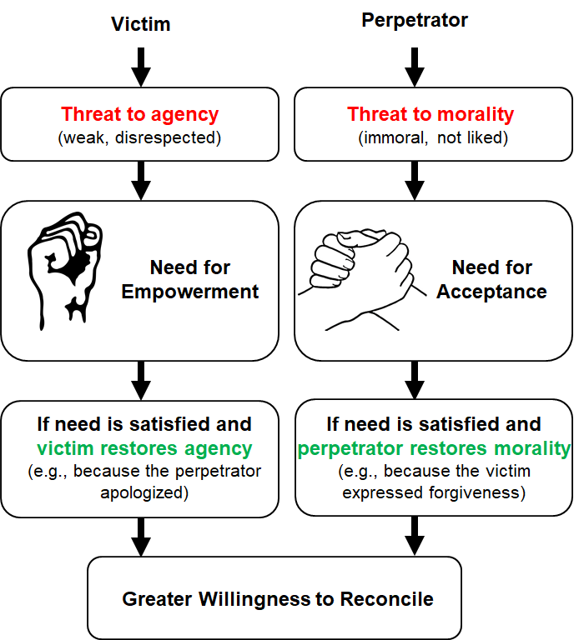

Fig 1. Identity-related processes in reconciliation according to the needs-based model. Following the transgression, each party experiences a threat to a particular dimension of their identity. Victims feel weak, not-in-control, and disrespected, and need empowerment to repair the agency dimension of their identity. Perpetrators, who feel that the moral identity is threatened and fear social exclusion, need acceptance. When the perpetrators satisfy the victims’ need for empowerment (e.g., by apologizing and recognizing their value), and the victims satisfy the perpetrators’ need for moral acceptance (e.g., by forgiving and sympathizing with them), the positive identities of both parties are restored. As a result, both sides are more willing to reconcile with each other.

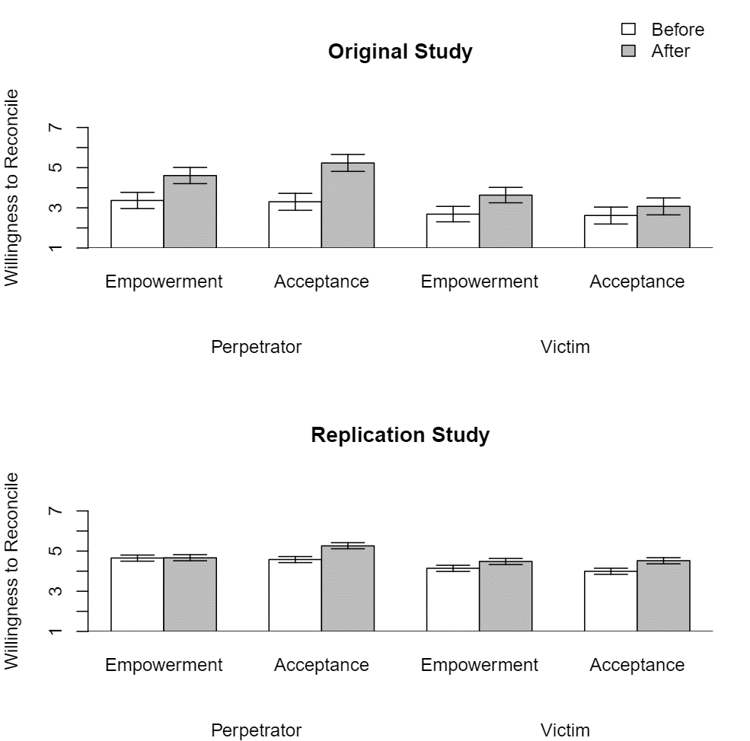

Fig 2. Willingness to reconcile among victims and perpetrators in contexts of interpersonal transgressions, both before and after receiving a message of empowerment or acceptance from the other party to the conflict. The upper part of the figure presents the original results, reported by Shnabel and Nadler (2008, Study 4). The lower part presents the results of Baranski et al.’s (2020) replication study, which used a revised protocol developed based on a pilot study among undergraduates in the United States. The error bars represent 95% confidence intervals, aiding visual detection of significant differences between independent groups (but, notably, not between repeated measurements).

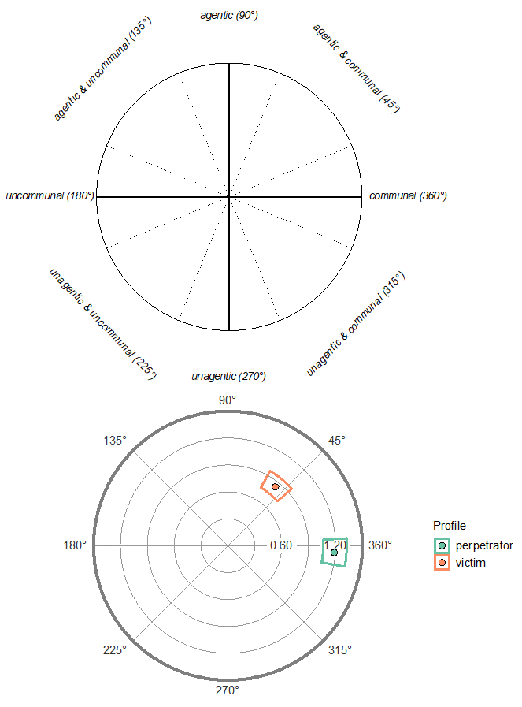

Fig 3. The Circumplex Model of Intergroup Goals is presented at the top. Means and confidence limits of the needs for agency and communion among victims and perpetrators in the ‘consumer’ context condition (Aydin et al., 2019b) are presented at the bottom. Participants in the ‘perpetrators’ condition report a lower need for agency (see vertical axis) and a higher need for communion (see horizontal axis) than participants in the ‘victims’ condition.

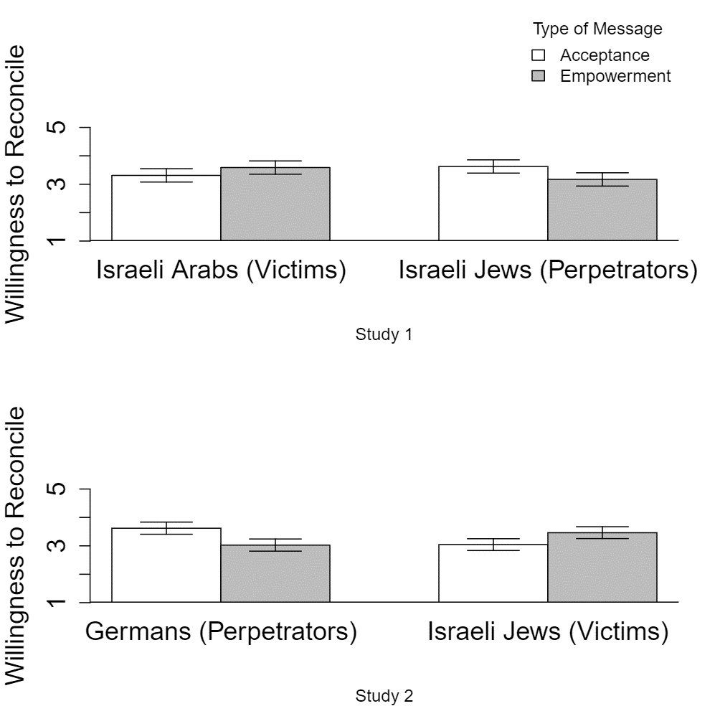

Fig 4. The willingness to reconcile following empowering and accepting messages from an outgroup representative among members of historical victim and perpetrator groups. Results for Israeli Arabs and Jews referring to the Kefar Kasem massacre (Shnabel et al., 2009; Study 1) are presented at the top; results for Jews and Germans referring to the Holocaust (Shnabel et al., 2009; Study 2) are presented at the bottom. The error bars represent 95% confidence intervals (which aid the visual detection of significant differences between independent groups, but not between repeated measurements).
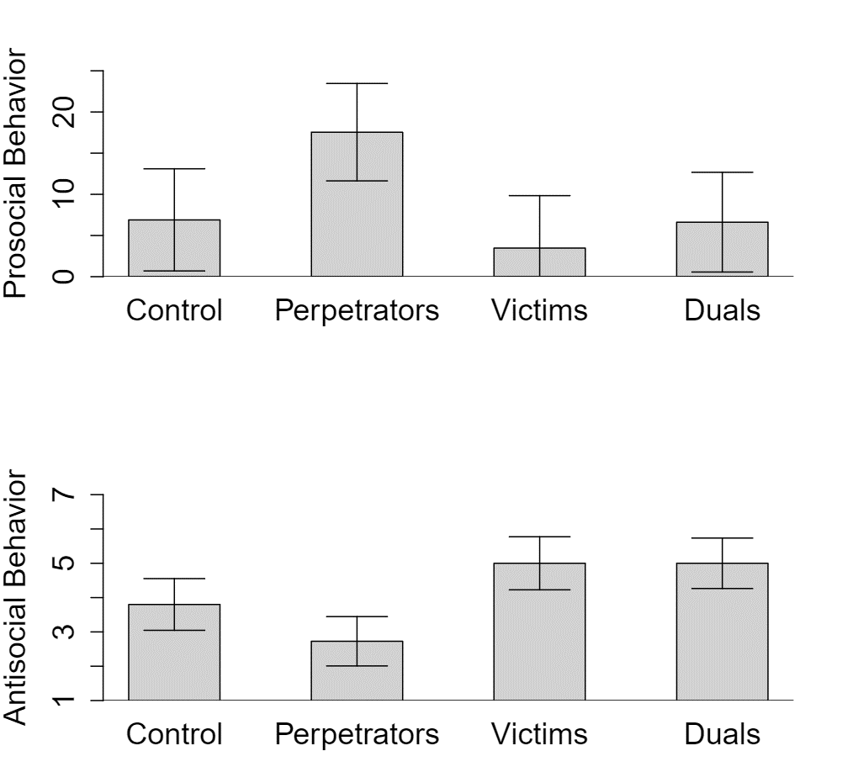

Fig 5. Antisocial and prosocial behavior of participants in a dyadic allocation task as a function of their social role—victims, perpetrators, or ‘duals’ (both victims and perpetrators) compared to control participants (neither victims nor perpetrators) (SimanTov-Nachlieli & Shnabel, 2014; Study 1). For prosocial behavior (upper part), participants could donate a part of their own final payoff, ranging from 0% to 100%, to the other player. For antisocial behavior, participants chose the difficulty level (ranging between 1 and 7) of a trivia question they asked the other player. Asking difficult questions practically meant blocking the other player’s influence on the final payoff. The error bars represent 95% confidence intervals.
Message from the Other Conflict-Party

Willingness to Reconcile

Sense of Agency

Message from a Third Party

Moral Image

Trust

Fig 6. The multiple mediation model testing the effects of messages from either the other party to the conflict or a neutral third party on victims’ and perpetrators’ sense of agency, moral image, trust in the other party, and willingness to reconcile (Shnabel et al., 2014; Study 1).

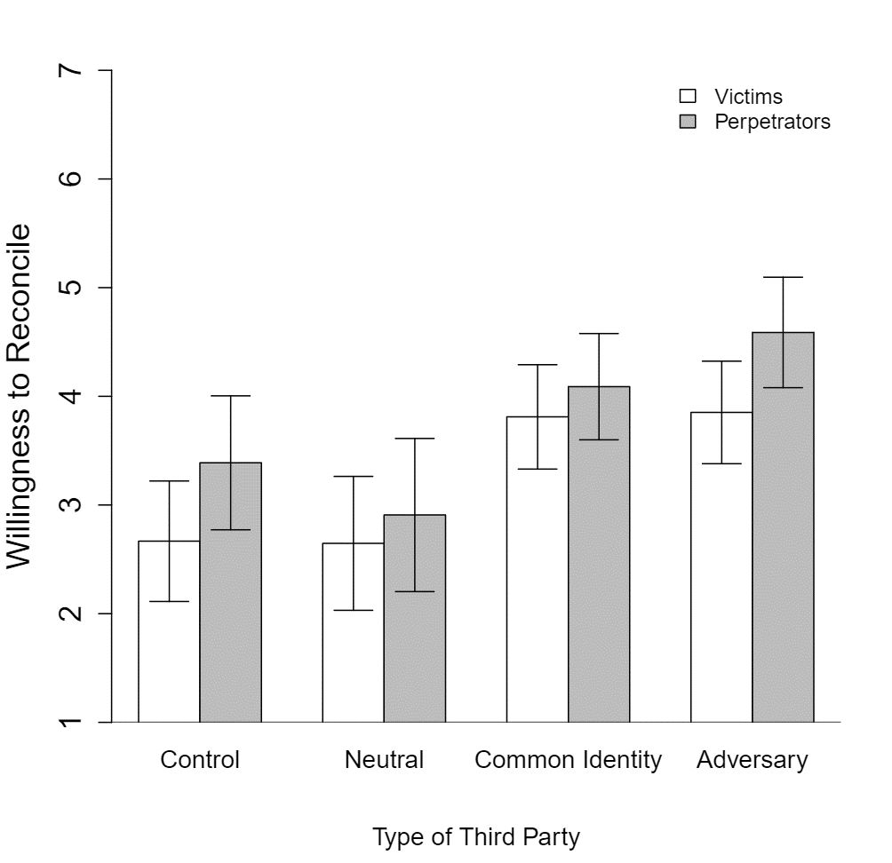

Fig 7. Members of victim and perpetrator groups’ willingness to reconcile with the other party to the conflict following identity-restoring messages from different sources: A Palestinian representative in the Adversary condition, a Jordanian representative in the Common Identity third-party condition, a United Nations representative in the Neutral third-party condition, and no message in the Control condition. The error bars represent 95% confidence intervals.

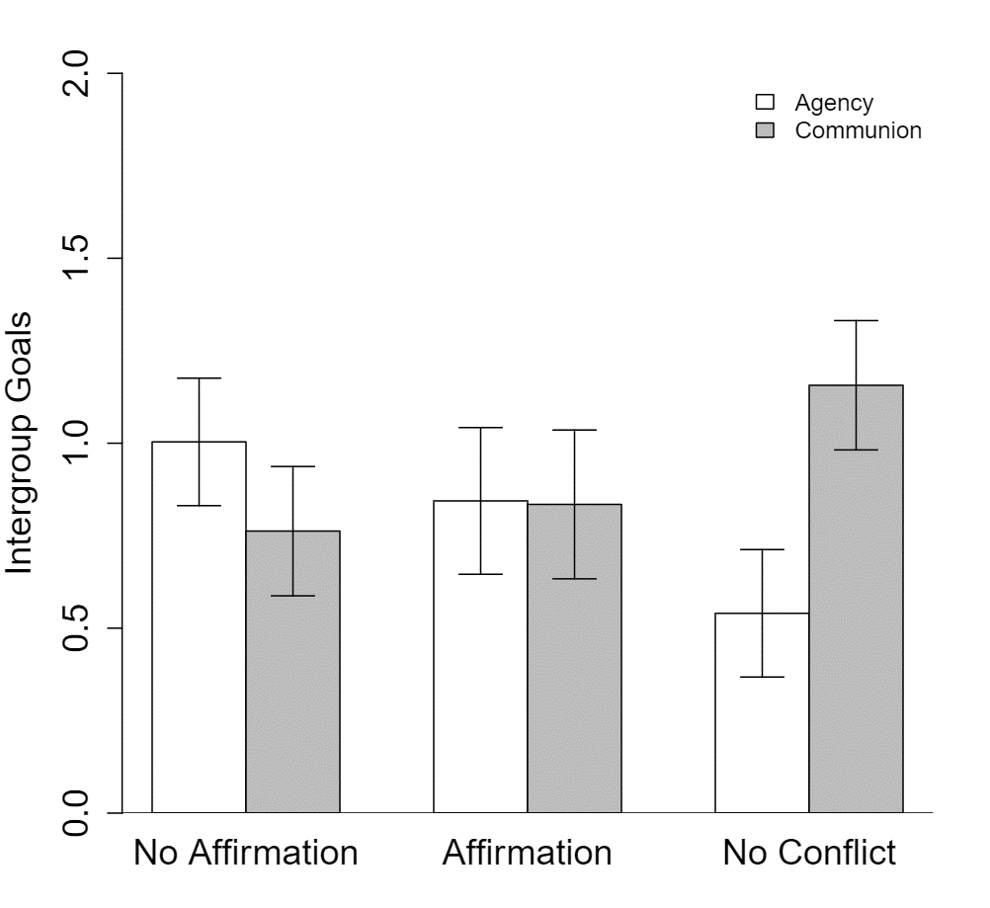

Fig 8. Group members’ pursuit of agentic and communal goals in the no-conflict condition, and in the dual conflict with or without agency-affirmation conditions (SimanTov-Nachlieli et al., 2018; Study 1). Specifically, Swiss citizens indicated their ingroup’s goals when interacting either with other groups in general (No Conflict condition) or with the EU (with which their ingroup had conflict). Participants in this conflict condition either completed a writing exercise in which they affirmed their ingroup’s agentic identity before their indicated their goals (Affirmation condition) or indicated their goals without completing this agency-affirmation exercise (No Affirmation condition). The error bars represent 95% confidence intervals (aiding visual detection of significant differences between independent groups, but not between within-participants measurements).

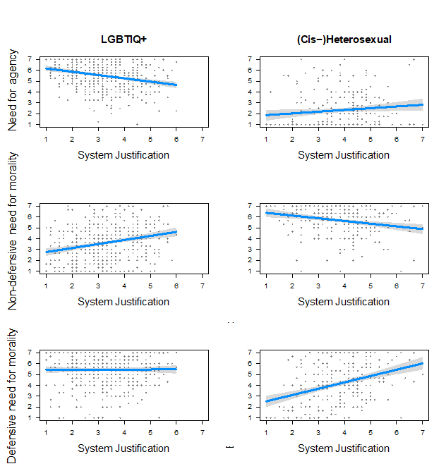

Fig 9. The association between system justification, the need for agency, and non-defensive and defensive needs for morality (Hässler, et al., 2019; Study 1) among members of sexual and gender minorities (left-hand side) and cis-heterosexual individuals (right-hand side). The need for agency denotes the wish that one’s ingroup would have more influence in society, the non-defensive need for morality denotes the wish that one’s ingroup’s would behave more morally, and the defensive need for morality denotes the wish that the outgroup would acknowledge that it receives fair treatment from the ingroup (hence there is no need for one’s ingroup to change its behavior).
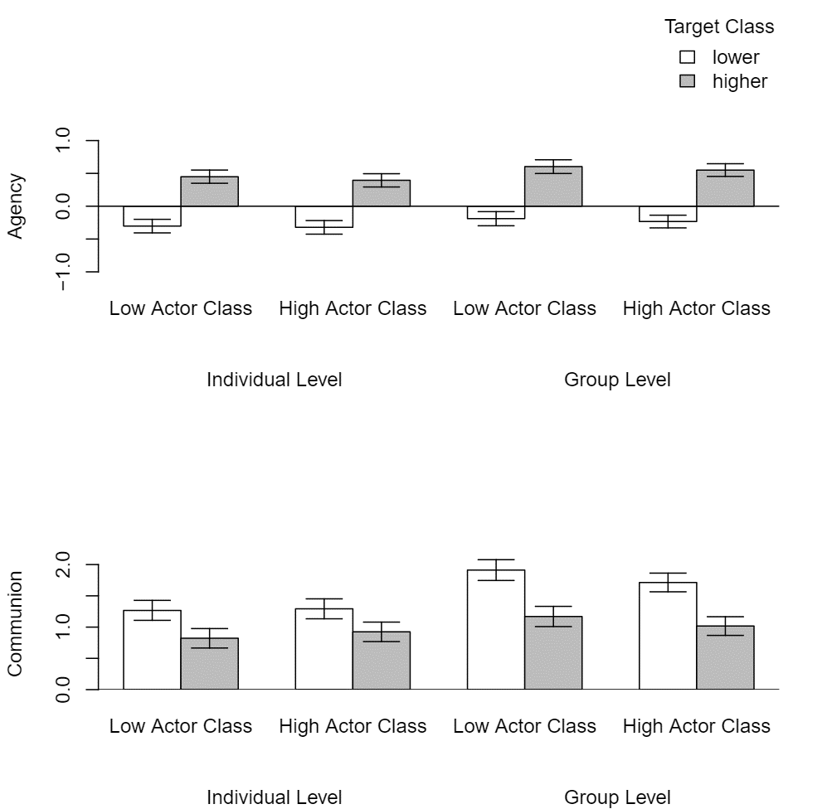

Fig 10. The pursuit of agentic (top) and communal (bottom) goals as a function of the actor’s class (i.e., whether the participant was assigned to the upper-class or lower-class condition), the target’s class (i.e., whether the participant refers to interactions with members of upper- or lower-class members), and level of goal pursuit (i.e., whether the participant refers to goal pursuit in interpersonal or intergroup interactions). The error bars represent 95% confidence intervals (aiding visual detection of significant differences between independent groups, but not between within-participants measurements).

The data needed to reproduce all the figures reported in this chapter are available at https://osf.io/y574k/.
We also conducted a pilot study (N = 156; see footnote 1 in Shnabel et al., 2014), which had a 2 (Role: victim vs. perpetrator) × 2 (Message Source: other conflict party vs. third party) × 2 (Message Type: empowerment vs. acceptance) design. It revealed that victims’ willingness to reconcile following an empowering message from the other conflict party was higher than their willingness to reconcile in the three other victim cells. Similarly, perpetrators’ willingness to reconcile following an accepting message from the other conflict party was higher than their willingness to reconcile in the three other perpetrator cells. The fact that messages from third parties, which conveyed acceptance to victims or empowerment to perpetrators did not seem to be especially effective, increased our confidence that it was appropriate to focus on empowering messages for victims and accepting messages for perpetrators.
According to Mischel, 2008, “psychologists treat other peoples’ theories like toothbrushes — no self-respecting person wants to use anyone else’s,” which hinders cumulative science.
The labels “advantaged” and “disadvantaged” groups capture this issue more accurately than the labels “majority” and “minority.” We therefore preferred to use them below, except for specific places in which we used the labels “majority/minority” for the sake of brevity, readability or consistency with the terminology used by other researchers whom we cite (e.g., Dovidio et al., 2009; Moscovici & Pérez, 2009).
When interpreting these findings, please note that although a factor analysis revealed that empowerment and acceptance loaded on different factors, they were strongly correlated. We therefore used residualized variables. When assessing the effects of empowering contact, we used the residuals of a regression in which acceptance predicted empowerment, and when assessing the effects of accepting contact, we used the residuals of a regression in which empowerment predicted acceptance. This allowed us to examine only the theoretically-relevant portion of the variance in each variable.

